ICX-AWX-Tower-Suite Guide

Contents

1. Git Project Setup 3

1.1 ICX-AWX-Tower-Suite Project 3

2. Credential Setup 5

2.1 ICX Login Credentials 5

2.2 AWX Login Credentials 7

2.2.1 Create Custom Credential Type 7

2.2.2 Add AWX Login Credentials 10

3. Inventory Setup 11

3.1 Switch Inventory 11

3.2 Switch Host 12

3.3 AWX Server Inventory 13

3.4 AWX Server Host 14

4. Template Management 15

4.1 AWX-Template-Management Template 15

4.2 Generate AWX-Template-Management Survey Prompt 17

4.3 Generate ICX Configuration Templates 18

5. Updating Playbooks and Templates 19

5.1 Manual update of project playbooks 19

5.2 Automated update of project playbooks 20

5.3 Automated update of project templates 22

6. Custom Template Creation 24

7. Image Management 26

7.1 Image Repository Creation 26

7.2 Import images to AWX server 27

7.3 View Image Repository Files 30

7.4 Copy image files to switch flash 32

7.4.1 Switch software upgrade by filename 32

7.4.2 Switch software upgrade by version 35

8. Setup AWX-ZTP 38

8.1 Launch "ZTP-Configure" 39

8.2 Workflow Creation 43

8.3 Adding Workflow to ZTP 56

# 1. Git Project Setup

## 1.1 ICX-AWX-Tower-Suite Project

To add the *ICX-AWX-Tower-Suite* playbooks to a project, first click on the **Projects** menu on the left, then click the **Add** button:

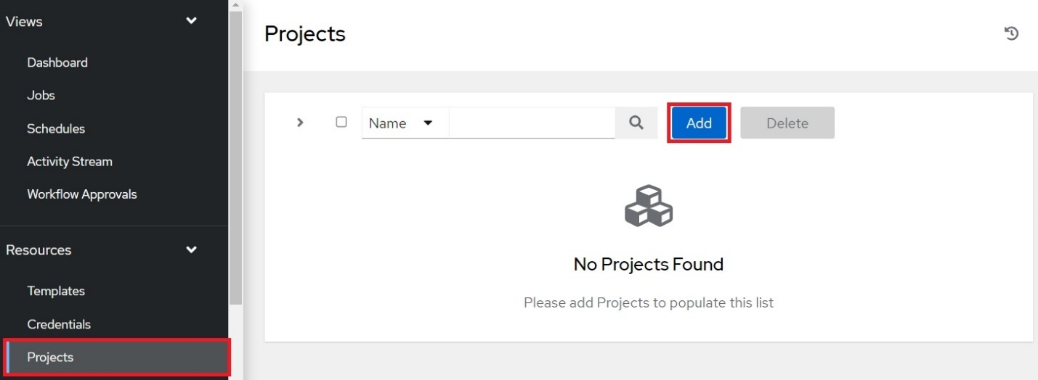

The **Create New Project** page will display. Enter the following into the required fields:

**Name**: Name the project "*ICX-AWX-Tower-Suite*"

**Source Control Type**: Select "*Git*"

**Source Control URL**: Type in "*https://github.com/steppb/ICX-AWX-Tower-Suite*".

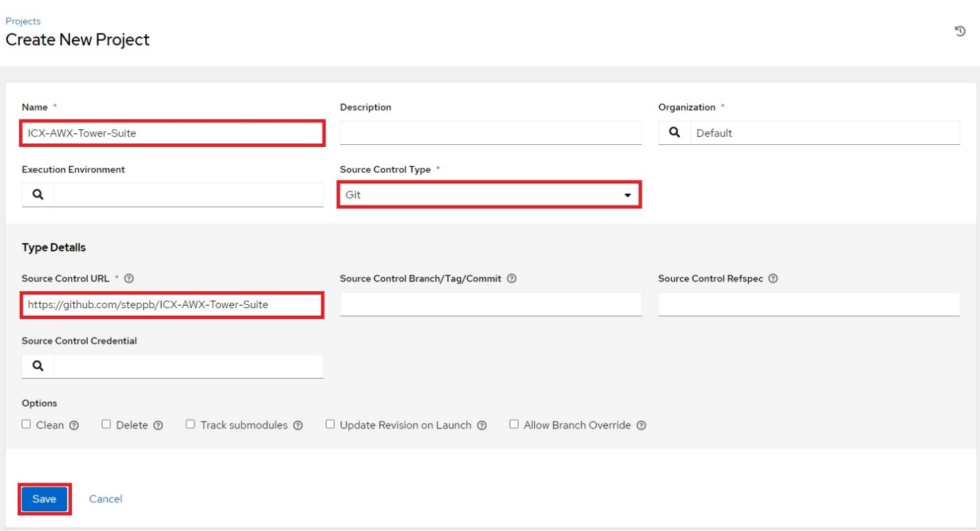

When you are finished, click **Save**.

Click **Projects** from the left navigation menu. At this point **ICX-AWX-Tower-Suite** will be added to the list of projects and it will begin syncing with the Github repo. When the project has finished syncing, the status will change to **Successful**:

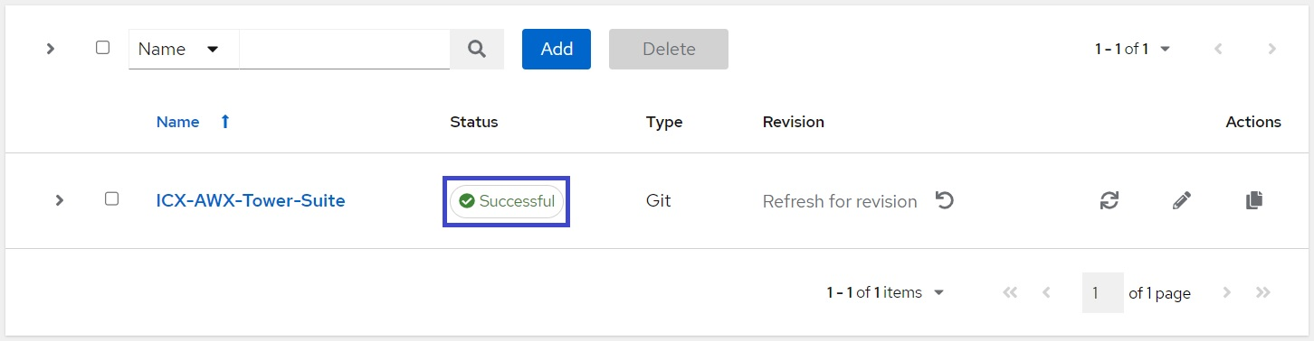

The status can be clicked to show a page detailing the syncing process.

# 2. Credential Setup

## 2.1 ICX Login Credentials

Click on the **Credentials** menu on the left, then click the **Add** button:

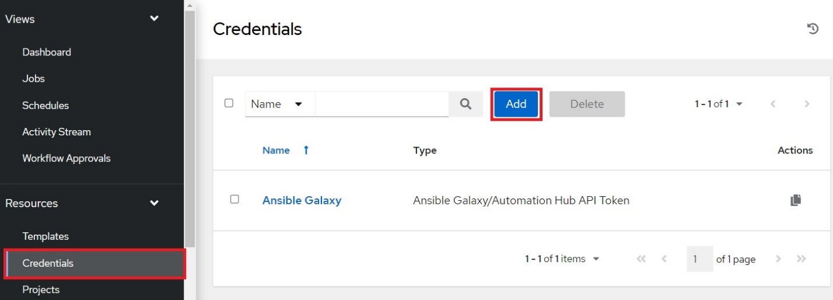

The **Create New Credential** page will display. Complete the following fields:

**Name**: Create a name for the credential set. Here it is named "*ICX Login*"

**Credential Type:** Select **Machine**.

**Username** & **Password:** Enter the username and password used to login to the switch.

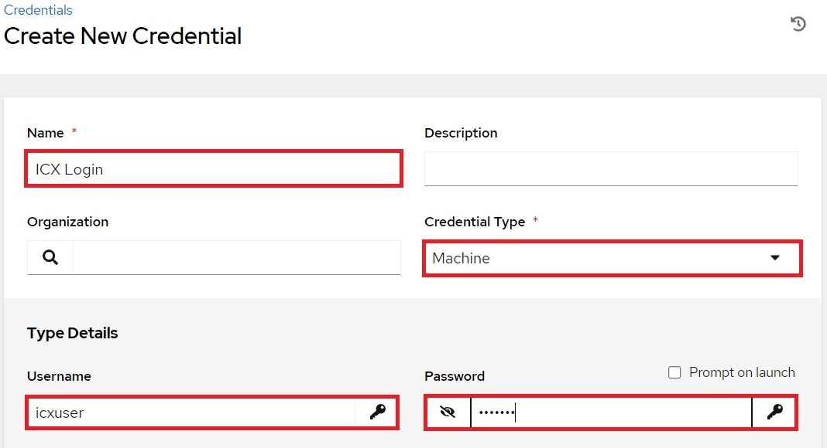

Scroll to the bottom of the **Create New Credential** page to add the enable username and/or password:

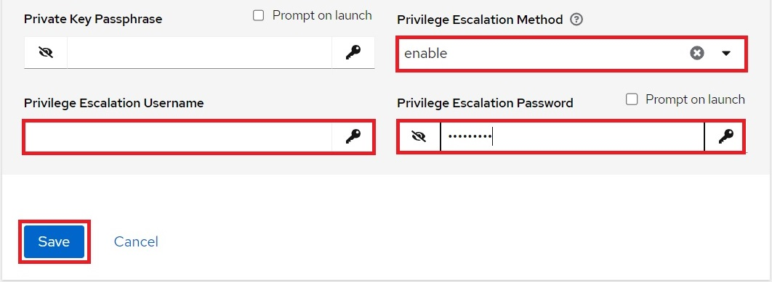

When finished, click **Save**.

## 2.2 AWX Login Credentials

Many playbooks within "*ICX-AWX-Tower-Suite*" require access to the AWX REST API as well as SSH access. A custom credential type will need to be created in order to add the credentials to AWX.

### 2.2.1 Create Custom Credential Type

First, click the **Credential Types** menu on the left, then click the **Add** button:

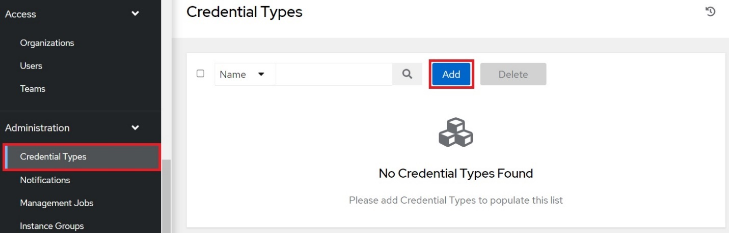

This opens the **Create new credential type** page.

Complete the following fields:

**Name**:Enter "AWX Server".

**Description**:(Optional) Enter a description.

**Input configuration**: Ensure **YAML** is selected. Then copy and paste the following into the box:

|  |
| --- |
| fields:  - id: guiusername  type: string  label: AWX GUI Username  - id: guipassword  type: string  label: AWX GUI Password  secret: true  - id: sshusername  type: string  label: AWX CLI Username  - id: sshpassword  type: string  label: AWX CLI Password  secret: true  - id: sudopassword  type: string  label: AWX CLI Sudo Password  secret: true  help_text: Leave blank to use CLI Password for Sudo  required:  - guiusername  - guipassword  - sshusername  - sshpassword |

**Injector configuration**: Ensure **YAML** is selected. Then copy and paste the following into the box.

|  |
| --- |
| extra_vars:  awxssh_pass: '{{sshpassword}}'  awxssh_sudo: '{{sudopassword|default(sshpassword)}}'  awxssh_user: '{{sshusername}}'  awxlogin_pass: '{{guipassword}}'  awxlogin_user: '{{guiusername}}' |

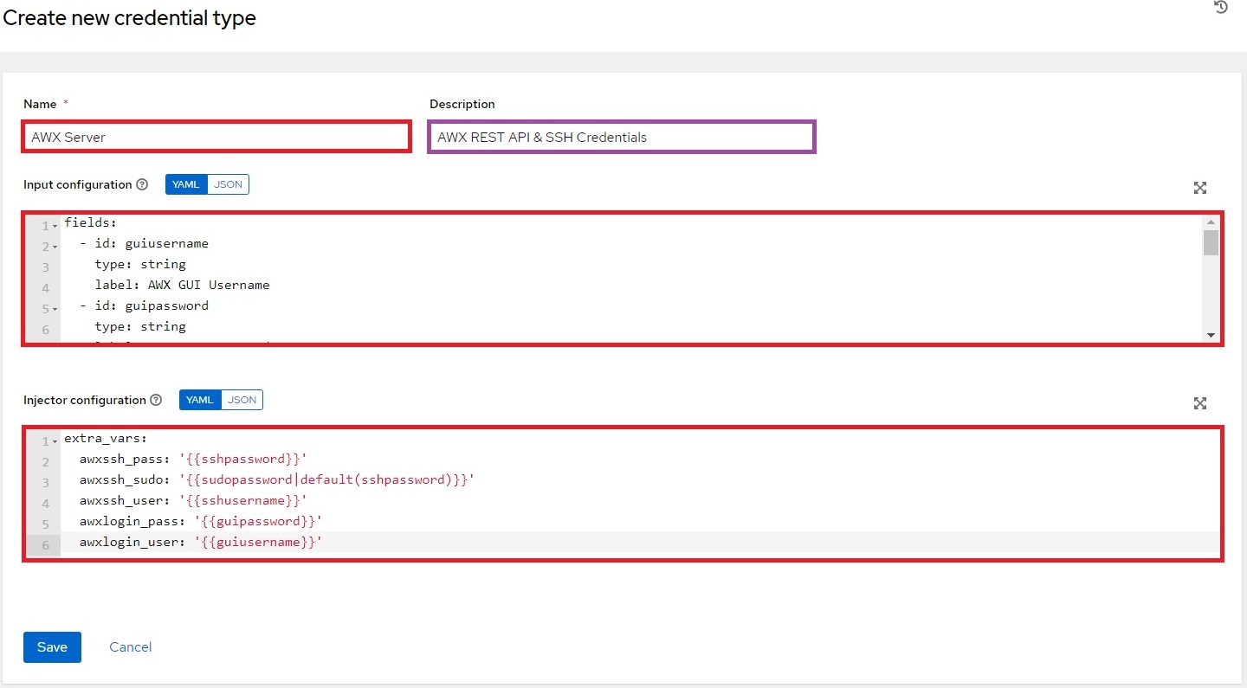

When you are finished, click **Save**.

Now that the custom credential type has been set up, a credential set for can be created.

### 2.2.2 Add AWX Login Credentials

Click on the **Credentials** menu on the left, then click the **Add** button:

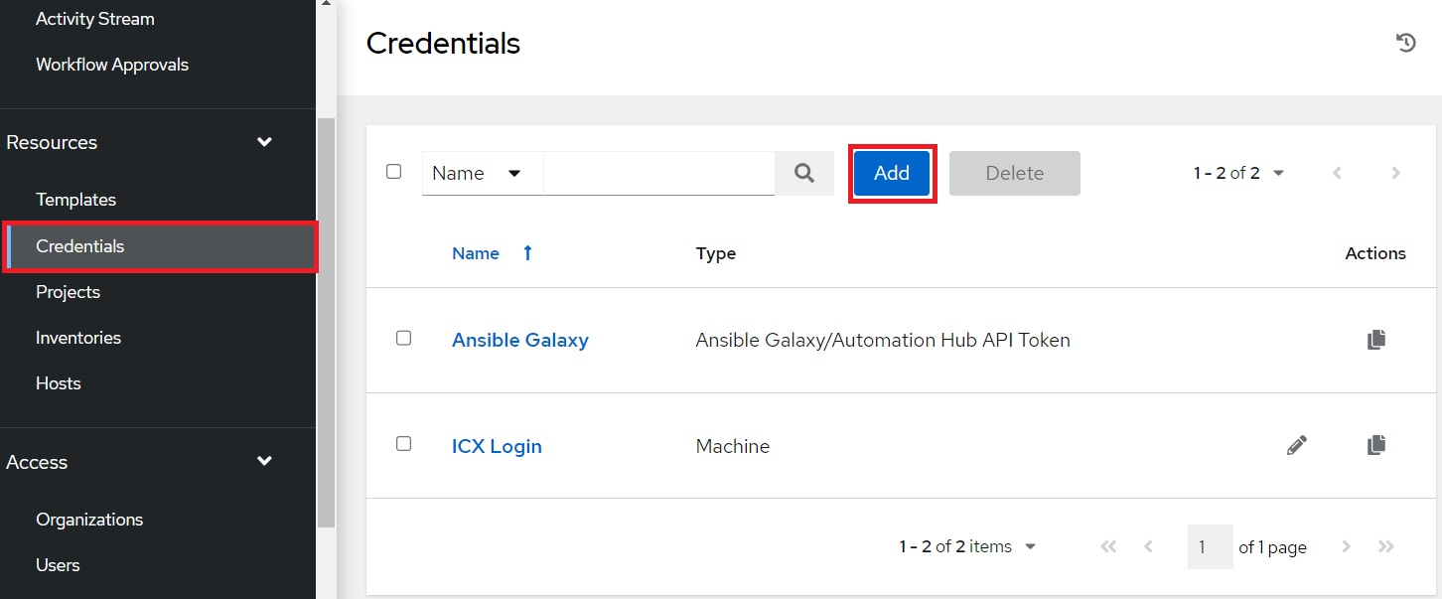

This opens the **Create New Credential** page. Enter the following into the required fields:

**Name**:Enter a name for the credential set.

**Credential Type**: Select **AWX Server**.

**AWX GUI Username** & **AWX GUI Password**: Enter credentials used to login to AWX.

**AWX CLI Username** & **AWX CLI Password**: Enter the SSH credentials used to access the server CLI.

**AWX CLI Sudo Password**: (Optional) Enter the Sudo password if it differs from CLI password.

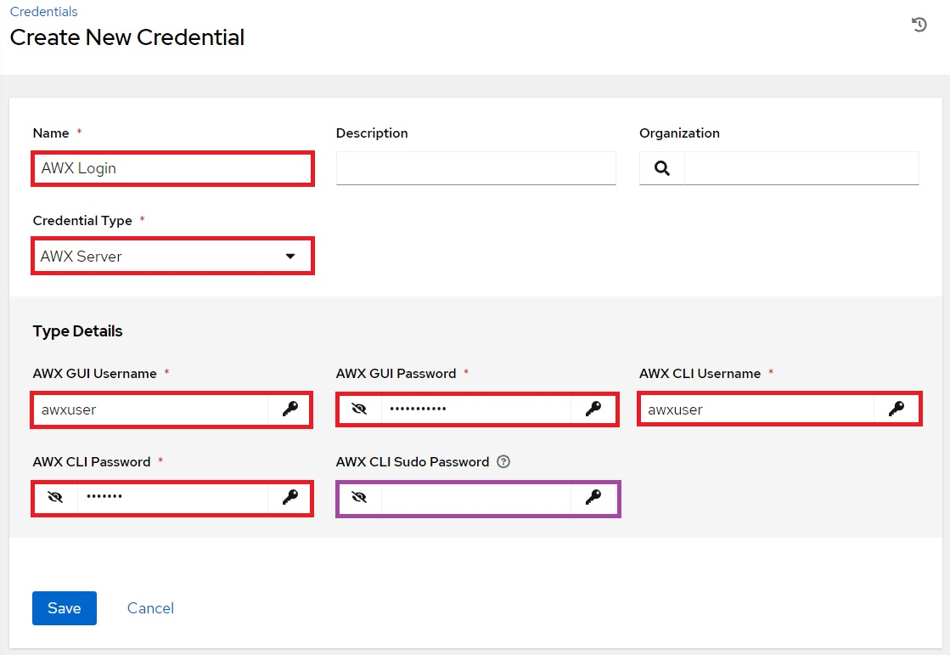

When you are finished, click **Save**.

# 3. Inventory Setup

## 3.1 Switch Inventory

An inventory for network devices will need to be setup before AWX can manage them.

Click the **Inventories** button from the left navigation bar. Click the **Add** button, then click **Add inventory** from the drop-down menu:

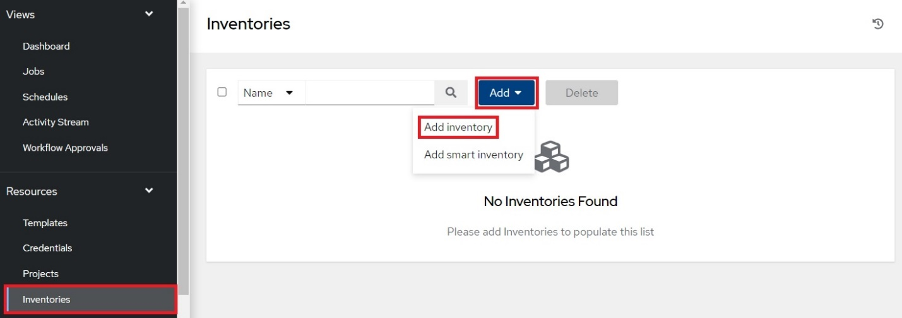

This opens the **Create new inventory** page. Complete the following fields:

**Name:** Enter a name for the Inventory. Here the inventory is named "*Ruckus Switches*".

**Organization:** Select the organization the inventory belongs to. Here "*Default*" is selected.

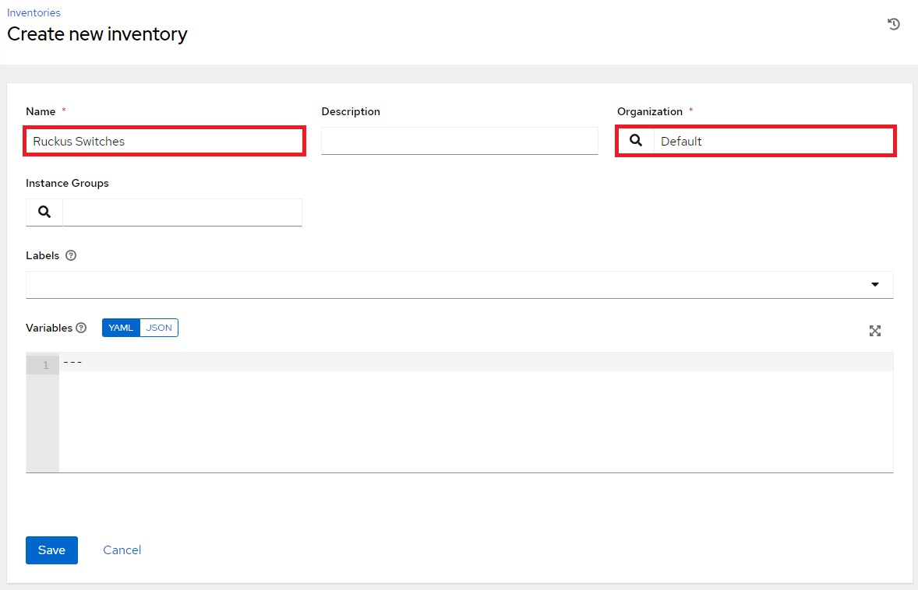

When you are finished, click the **Save** button.

## 3.2 Switch Host

Switches can now be added to the newly created inventory.

Click on the **Hosts** tab, then click the **Add** button:

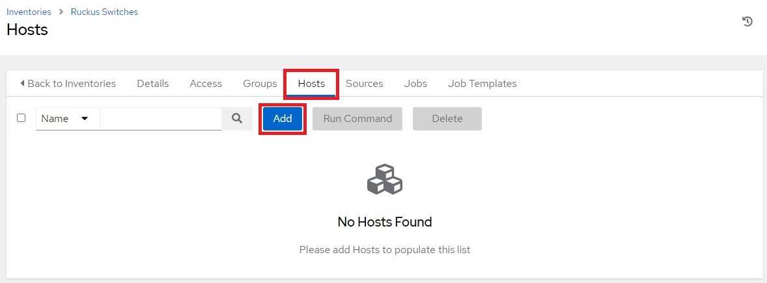

The **Create new host** page will display. Complete the following fields:

**Name**: Enter the hostname of the switch.

**Variables**:Type "**ansible_host:** " followed by the IP address of the switch.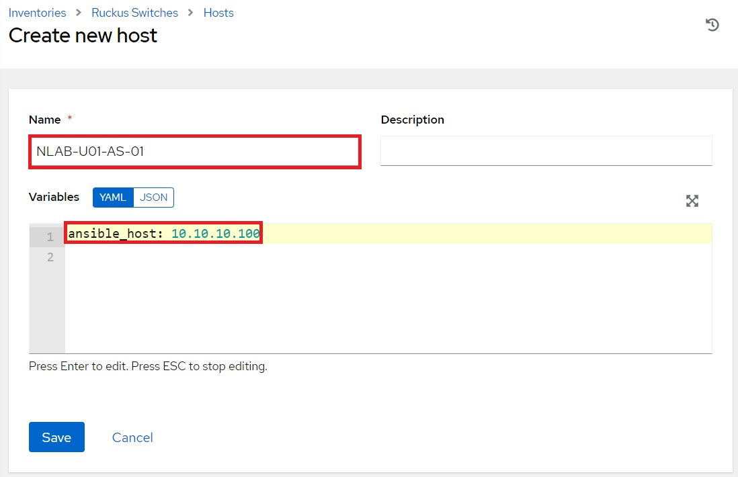

When finished, click **Save.**

## 3.3 AWX Server Inventory

An inventory for the AWX Server itself will need to be setup in order to launch templates that utilize the “*awx_management*” role.

Click the **Inventories** button from the left navigation bar. Click the **Add** button, then click **Add inventory** from the drop-down menu:

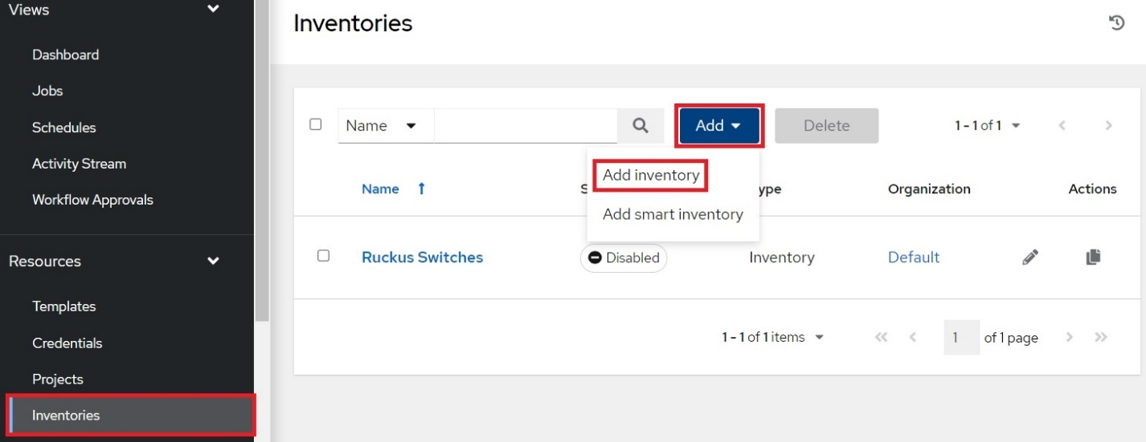

This opens the **Create new inventory** page. Complete the following fields:

**Name:** Enter a name for the Inventory. Here the inventory is named "*AWX Server*".

**Organization:** Select the organization the inventory belongs to. Here "*Default*" is selected.

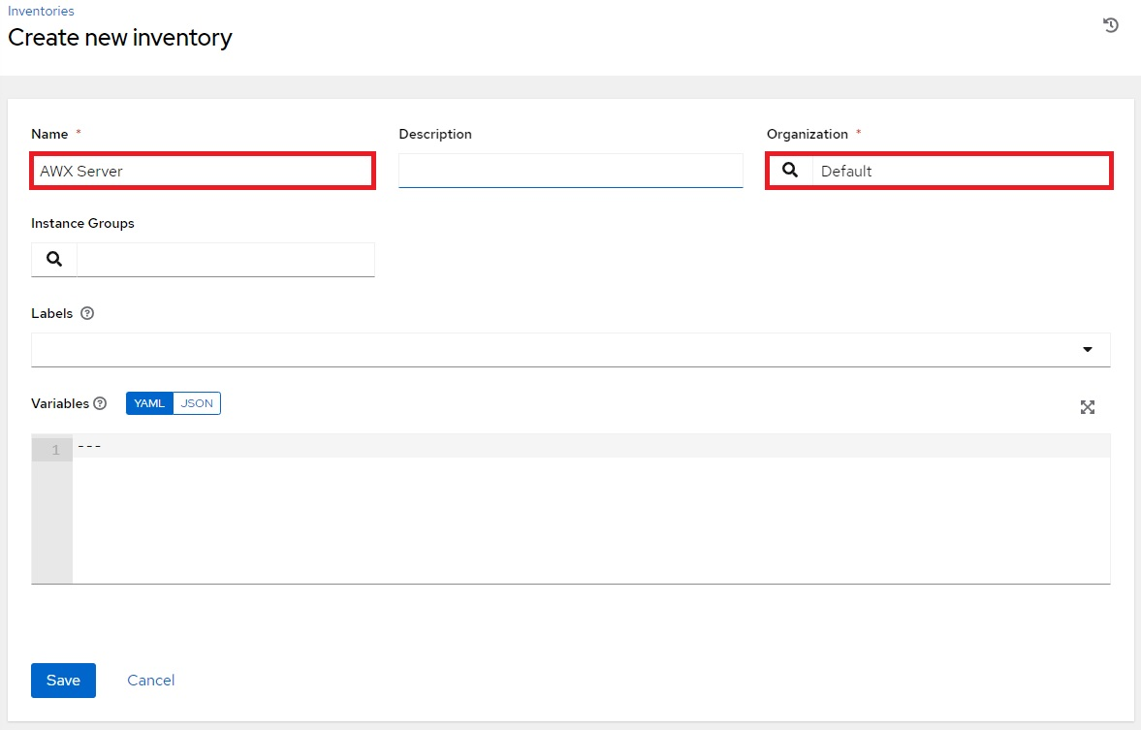

When you are finished, click the **Save** button.

## 3.4 AWX Server Host

Click the **Hosts** tab, then click the **Add** button:

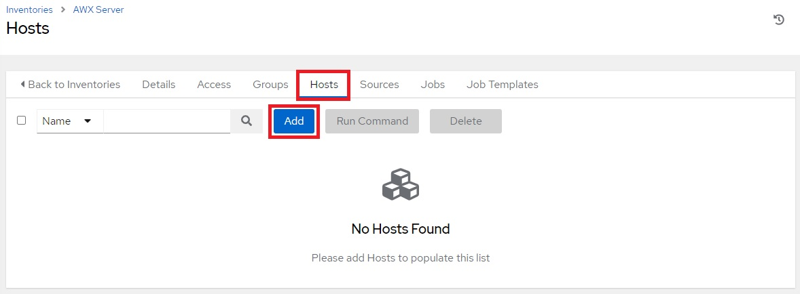

This opens the **Create new host** page. Complete the following fields:

**Name**: Enter the hostname of the AWX server. Here it is called "*awxserver*".

**Variables**:Type in "*ansible_host:* " followed by the IP address of the AWX server.

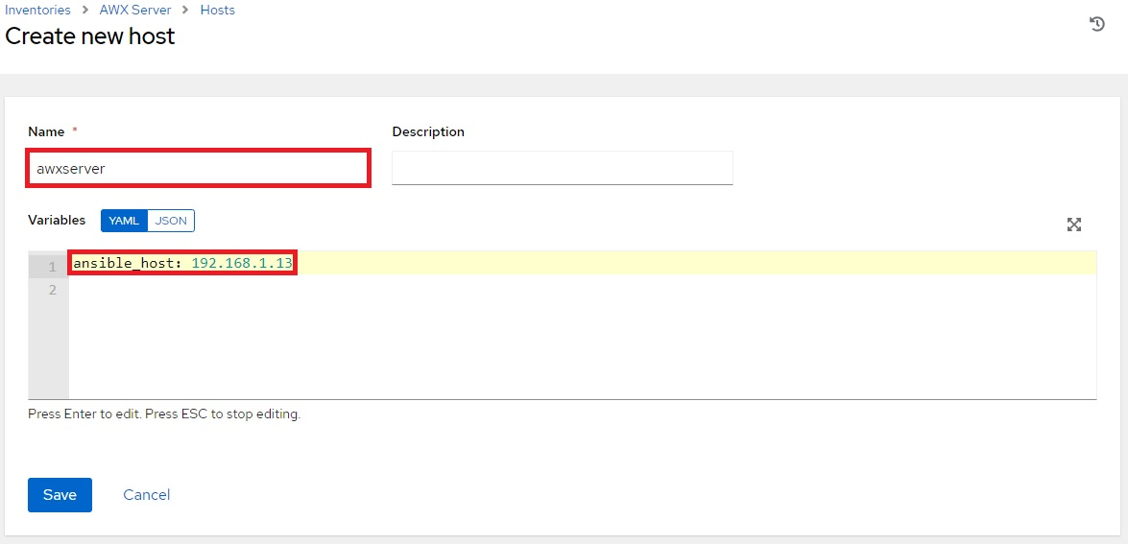

Click **Save** when done, and the AWX server will be added to the Inventory's list of hosts.

# 4. Template Management

The *awx_management* role contains the *template_management* sub-role which simplifies creating and updating templates for the *ICX-AWX-Tower-Suite* templates within AWX.

## 4.1 AWX-Template-Management Template

Click the **Templates** button from the left navigation bar. Click the **Add** button, then click **Add job template** from the drop-down menu:

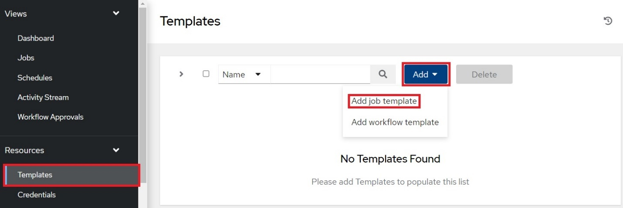

This opens the **Create New Job Template** page. Complete the following fields:

**Name**:Enter a name for the template. Here it is named "*AWX-Template-Management*"

**Description**: (Optional) Enter a description of the template.

**Inventory**: Select the inventory that contains the AWX server. Here it is "*AWX Server*"

**Project**: Select **ICX-AWX-Tower-Suite**.

**Playbook**: Select **AWX-Template-Management.yml**.

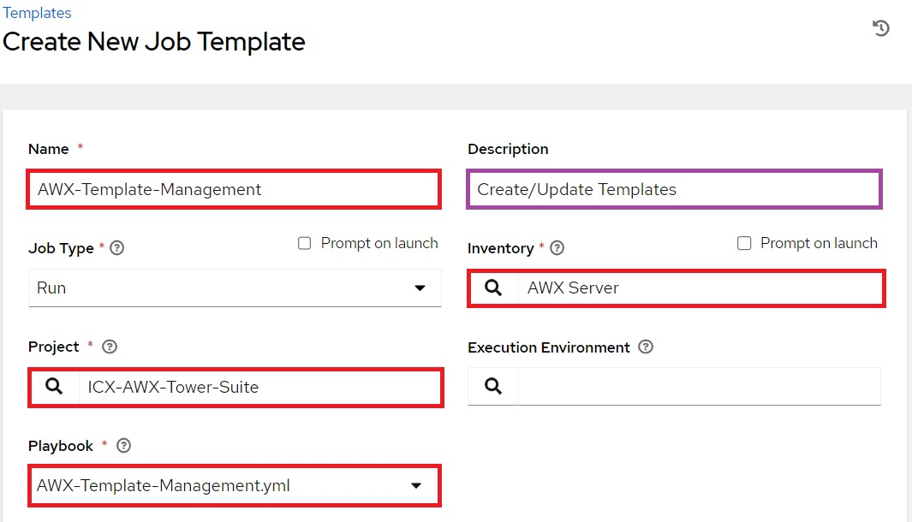

**Credentials**:Click the  button to open the **Select Credentials** window:

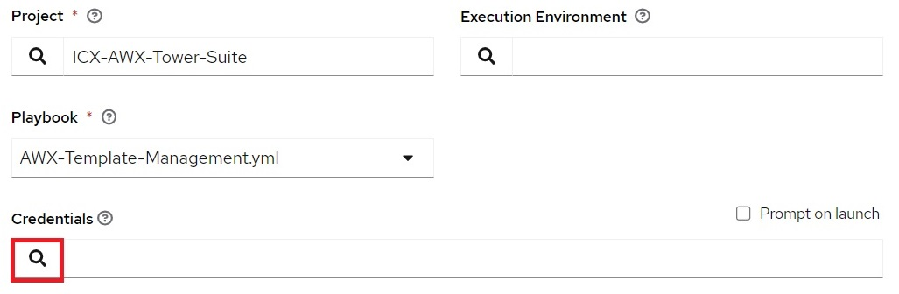

Select the custom credential type in the **Selected Category** drop-down menu, then select the AWX Login credentials:

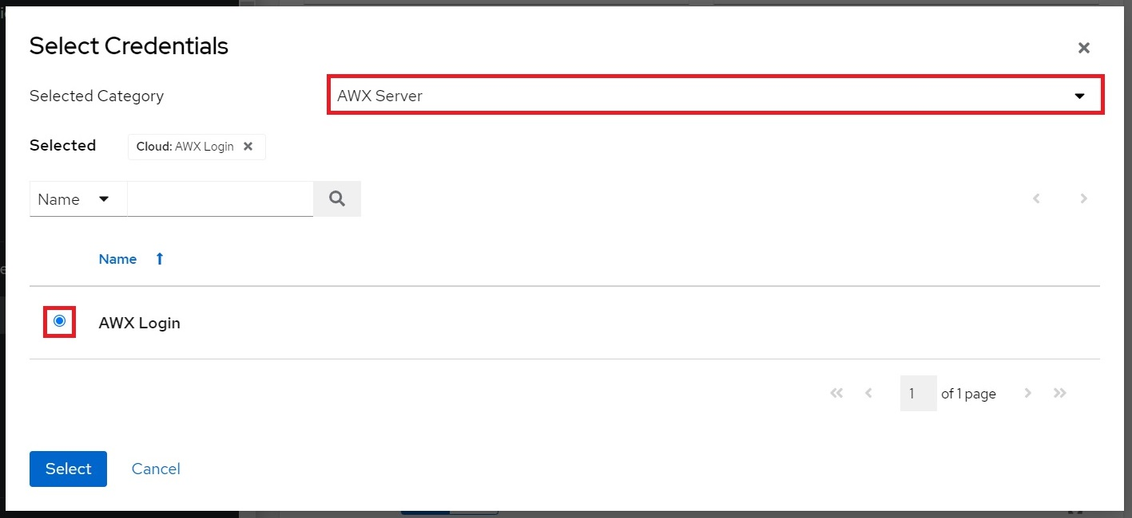

Click **Select** when done, then click **Save** to save the template.

## 4.2 Generate AWX-Template-Management Survey Prompt

Click the **Templates** button from the left navigation bar. Then click the launch button next to **AWX-Template-Management**:

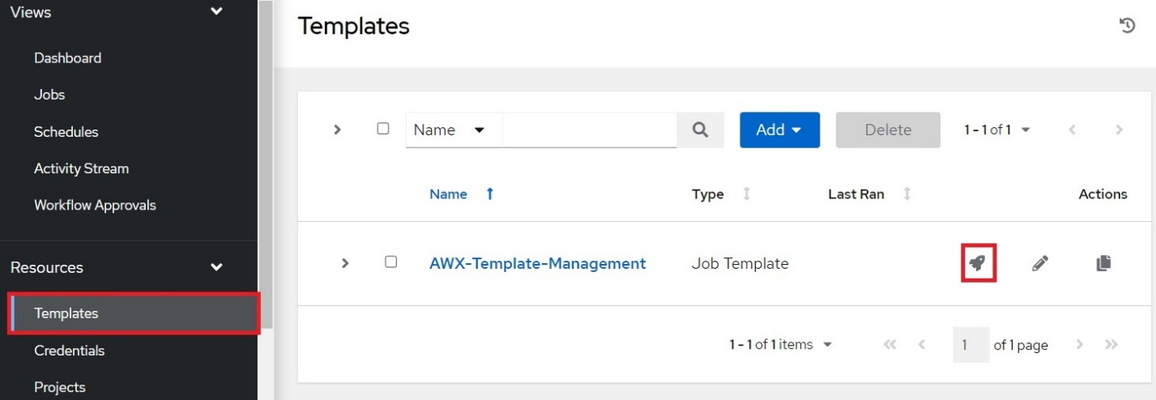

Upon successful completion, the output page will display a status:

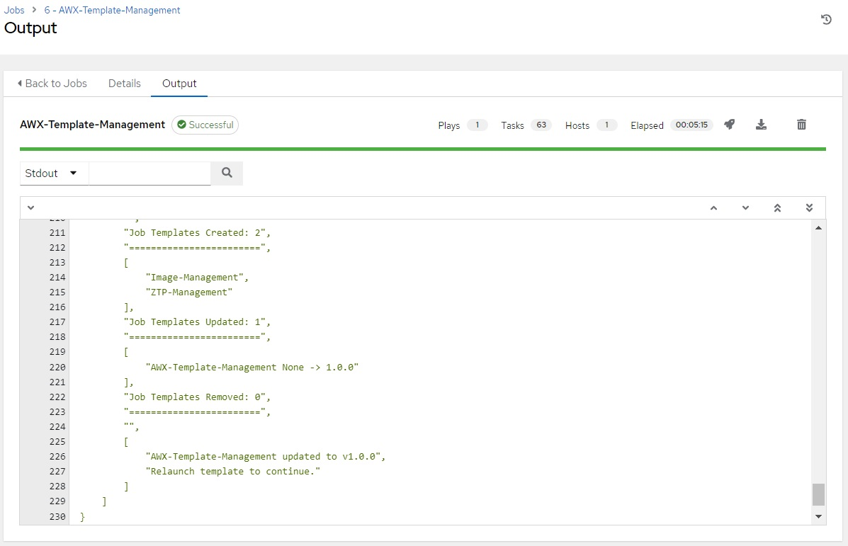

As shown in the status output, the *Image-Management* and *ZTP-Management* templates have been created and the *AWX-Template-Management* template has been updated.

## 4.3 Generate ICX Configuration Templates

Click the **Templates** button from the left navigation bar. Then click the launch button next to **AWX-Template-Management**:

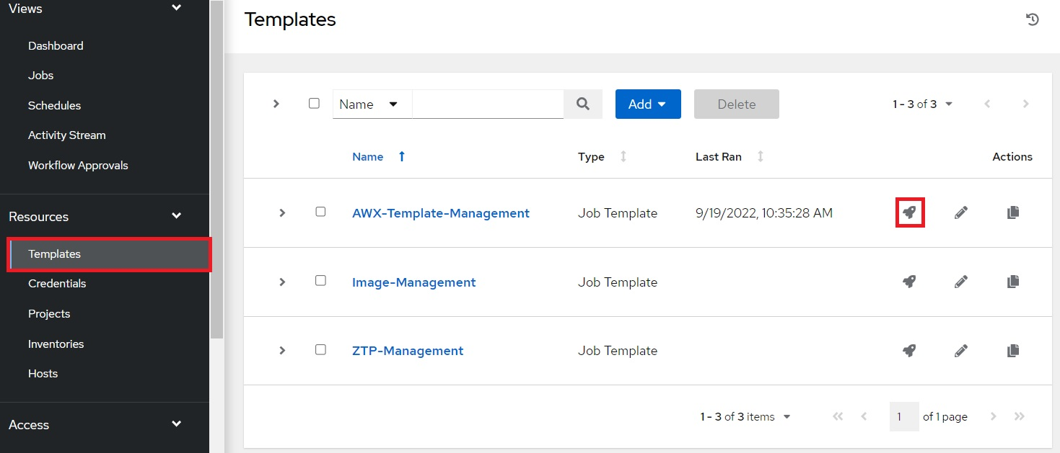

Complete the following field in the Survey Prompt window that appears:

**Template management function**: Select **Create/Update Templates**.

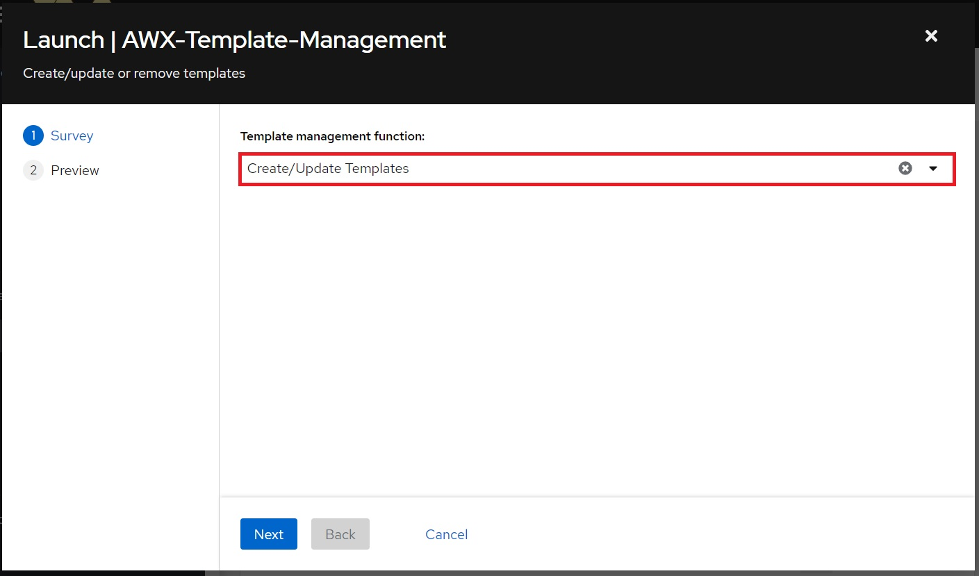

Click **Next** when finished, then click **Launch** on the Preview tab to run the template.

# 5. Updating Playbooks and Templates

Git projects by default do not update local playbooks when changes occur upstream. The following section covers manual and automated methods of updating the templates and playbooks in a project.

## 5.1 Manual update of project playbooks

Click the **Projects** button from the left navigation window, then click the refresh () button to sync the **ICX-AWX-Tower-Suite** playbooks with the upstream repository:

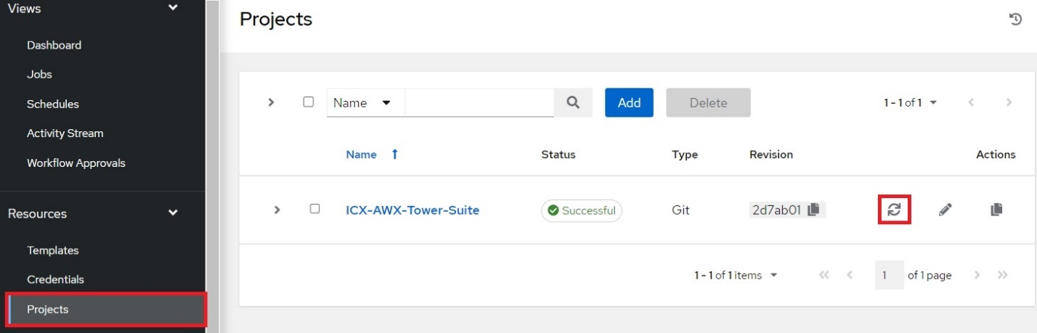

Project templates can be updated by rerunning the "*AWX-Template-Management*" template from the instructions in the "*Generating New Templates*" section above.

## 5.2 Automated update of project playbooks

The following will run through a schedule-based method to update both the playbooks and templates.

Click the **Projects** button from the left navigation menu. Then click the **ICX-AWX-Tower-Suite** project:

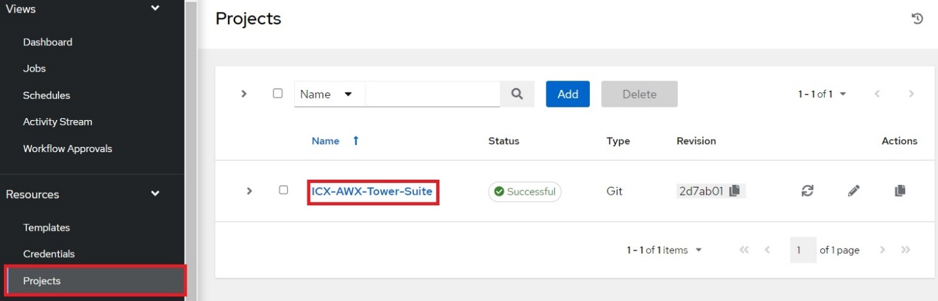

Click the **Schedules** tab, then click the **Add** button:

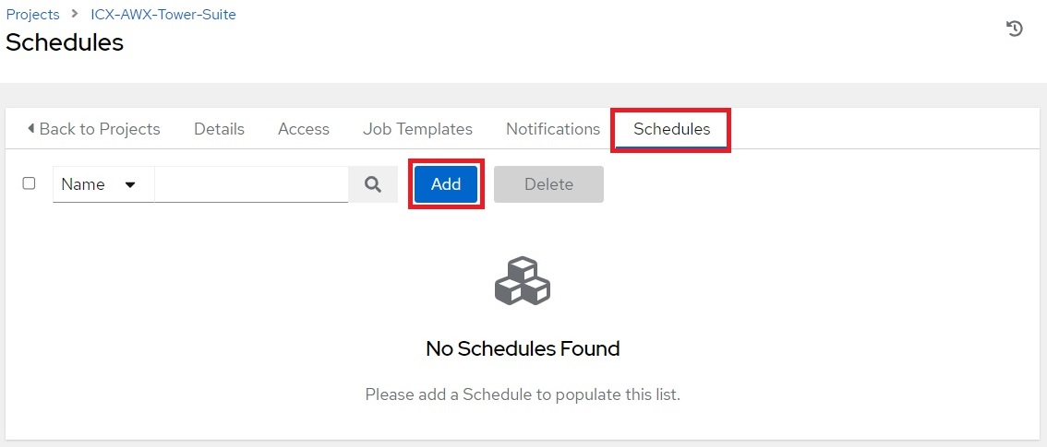

This will open the **Create New Schedule** page. Complete the following fields:

**Name**: Name of the schedule.

**Start date**: First day the schedule takes effect.

**Start time**: Time of first run.

**Local time zone**: Time zone local to AWX Server.

**Run frequency**: How often the sync will occur.

The following is an example of a sync that will occur daily at 11:00PM ET starting 9/20/2022:

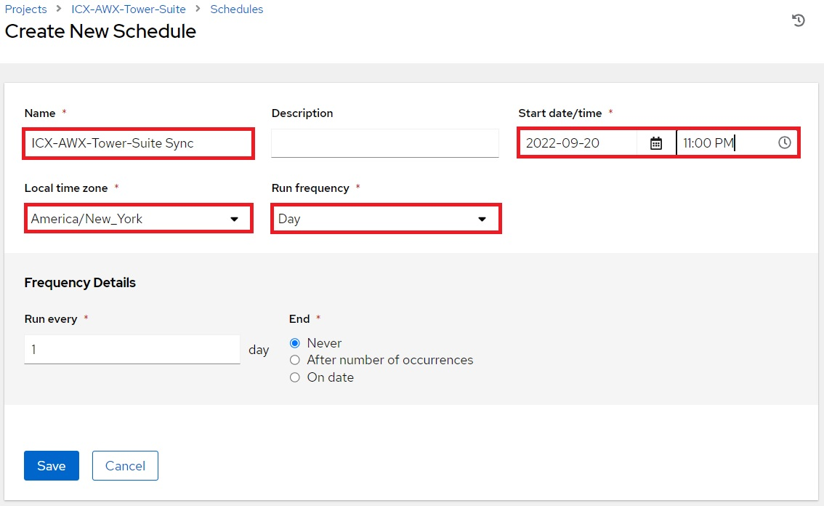

When finished, click **Save**.

## 5.3 Automated update of project templates

Click the **Templates** button from the left navigation bar, then click "*AWX-Template-Management*":

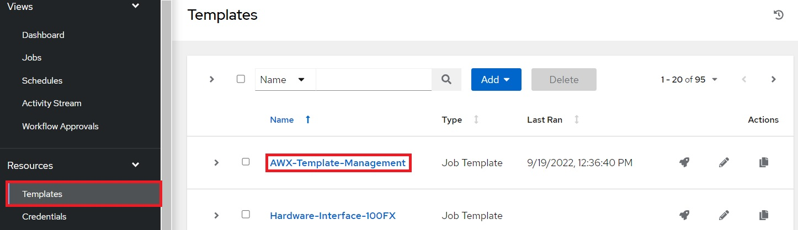

Click the **Schedules** tab, then click the **Add** button:

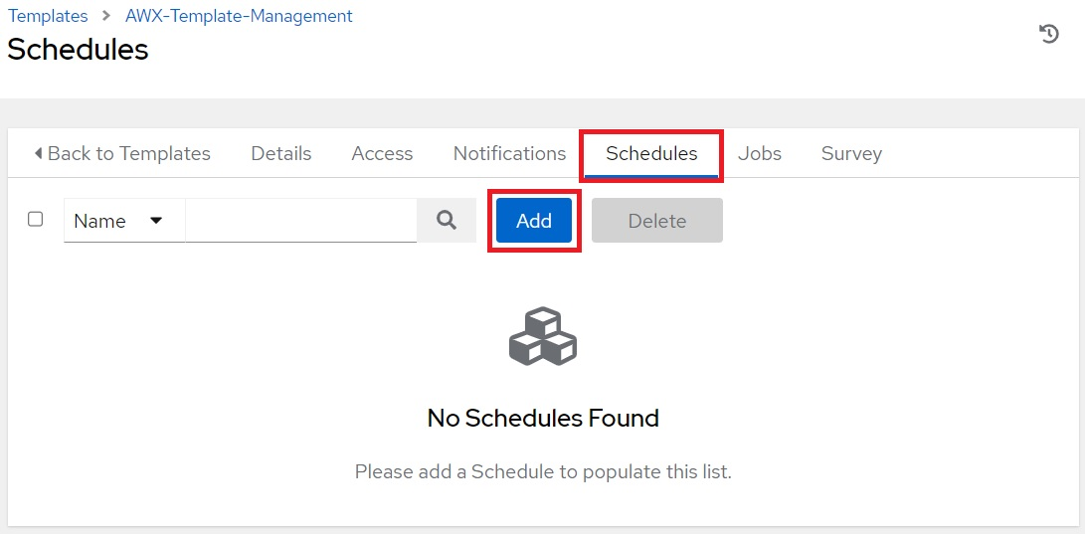

This will open the **Create New Schedule** page. Complete the following fields:

**Name**: Name of the schedule.

**Start date**: First day the schedule takes effect.

**Start time**: Time of first run.

**Local time zone**: Time zone local to AWX Server.

**Run frequency**: How often the sync will occur.

The following is an example of a sync that will occur daily at 11:30PM ET starting 9/20/2022:

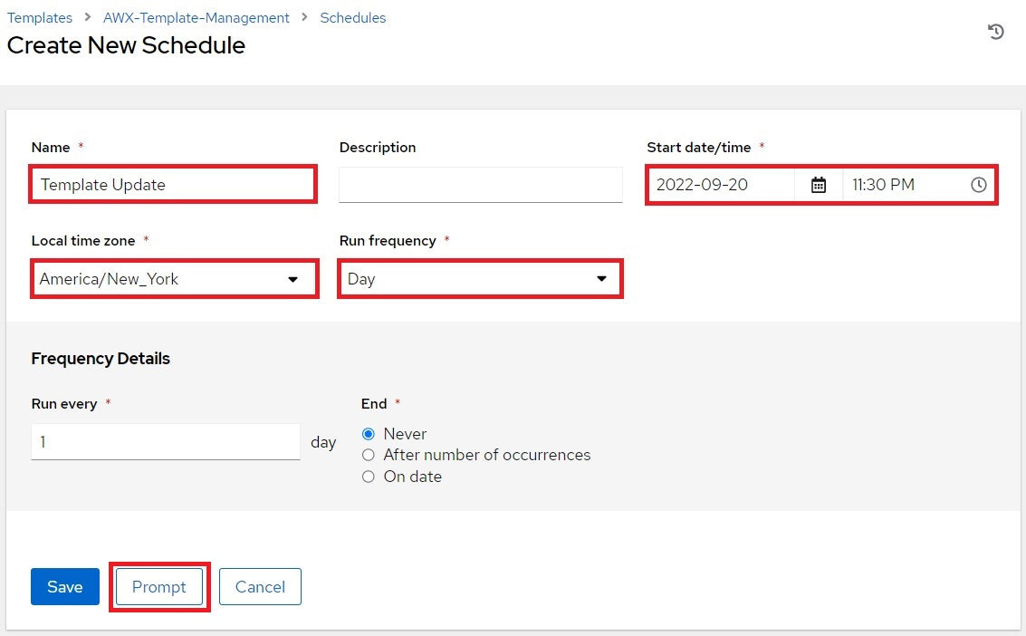

When finished, click the **Prompt** button to open the prompt window.

Complete the following field on the Survey prompt:

**Template management function**: Select **Create/Update Templates**.

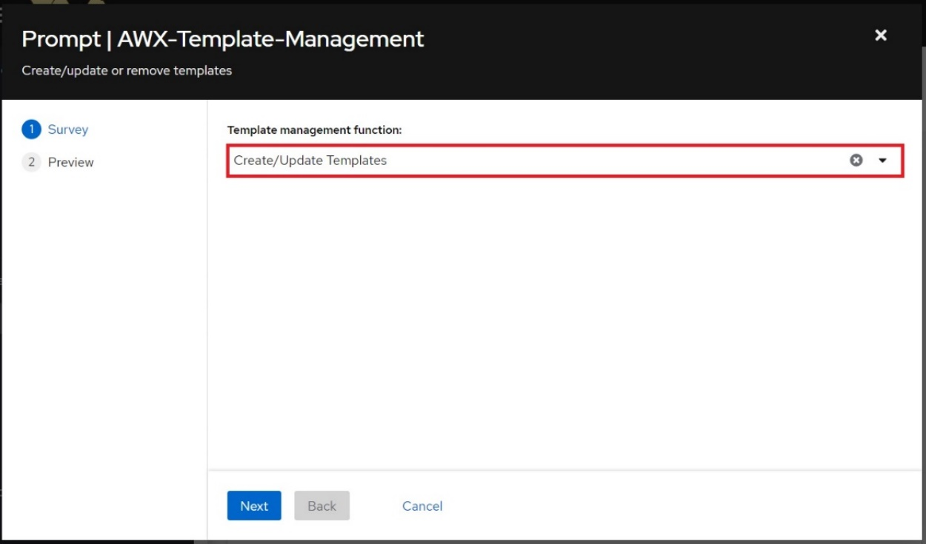

Click **Next** when finished, then click **Save** on the next tab to save the prompt and close the window. Click **Save** at the bottom of the **Create New Schedule** page to schedule the template.

# 6. Custom Template Creation

The ”*ICX-AWX-Tower-Suite*” project contains a playbook named “*ICX-Custom-Config.yml*”. The “*AWX-Template-*Management” template does not create a template for this playbook. This playbook can be used to create custom configuration templates. The following provides an example of how to create a custom configuration template.

Click the **Templates** button from the left navigation bar. Click the **Add** button, then click **Add job template** from the drop-down menu:

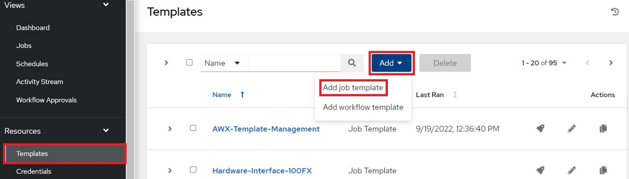

This opens the **Create New Job Template** page. Complete the following fields:

**Name**:Enter a name for the template.

**Inventory**: Click the checkbox next to **Prompt on launch**.

**Project**: Select **ICX-AWX-Tower-Suite**.

**Playbook**: Select **icx_config_playbooks/ICX-Custom-Config.yml**.

**Credentials**: Click the checkbox next to **Prompt on launch**.

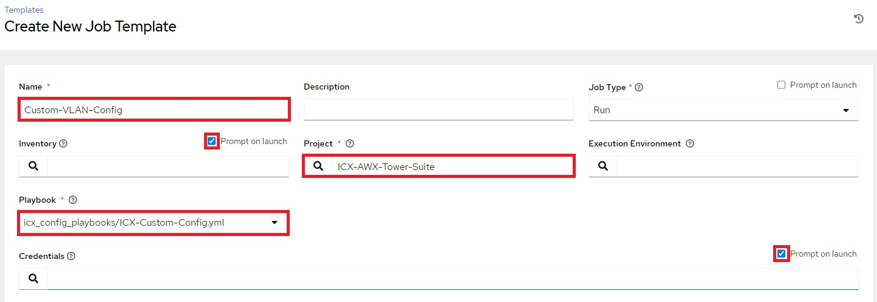

**Variables**:The switch config will be written as a variable definition.

**Limit**: Click the checkbox next to **Prompt On launch.** This is required for ZTP.

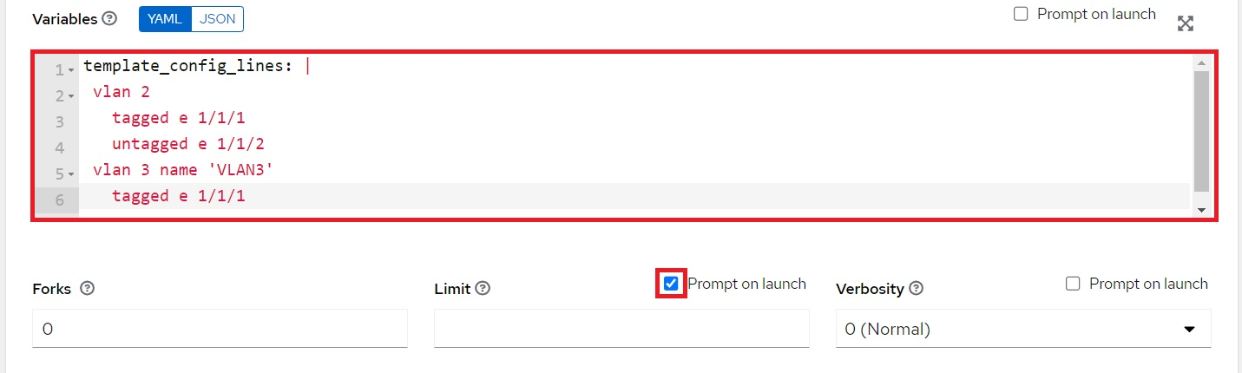

When finished, click **Save**.

Note: The “*ICX-Custom-Config*” playbook pushes the configuration that is defined in the “*template_config_lines*” variable to the switch without performing error checking. Custom templates should be tested first before mass deployment.

# 7. Image Management

The *awx_management* role contains the *image_management* sub-role which utilizes AWX to manage the storage and deployment of application and boot-monitor images for the ICX platform. Currently only ICX7XXX series switches are supported.

## 7.1 Image Repository Creation

Before binary images can be imported to the AWX server, a repository will need to be created in the project directory.

Click the **Templates** button from the left navigation bar, then click the launch button next to "*Image-Management*":

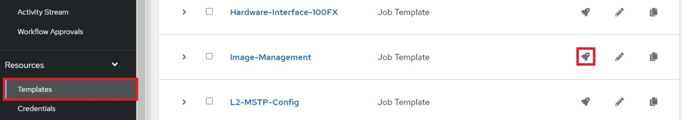

Complete the following field in the Survey Prompt window that appears:

**Image Repository Path**: Enter the full path to be created or use the default "*/opt/Images*".

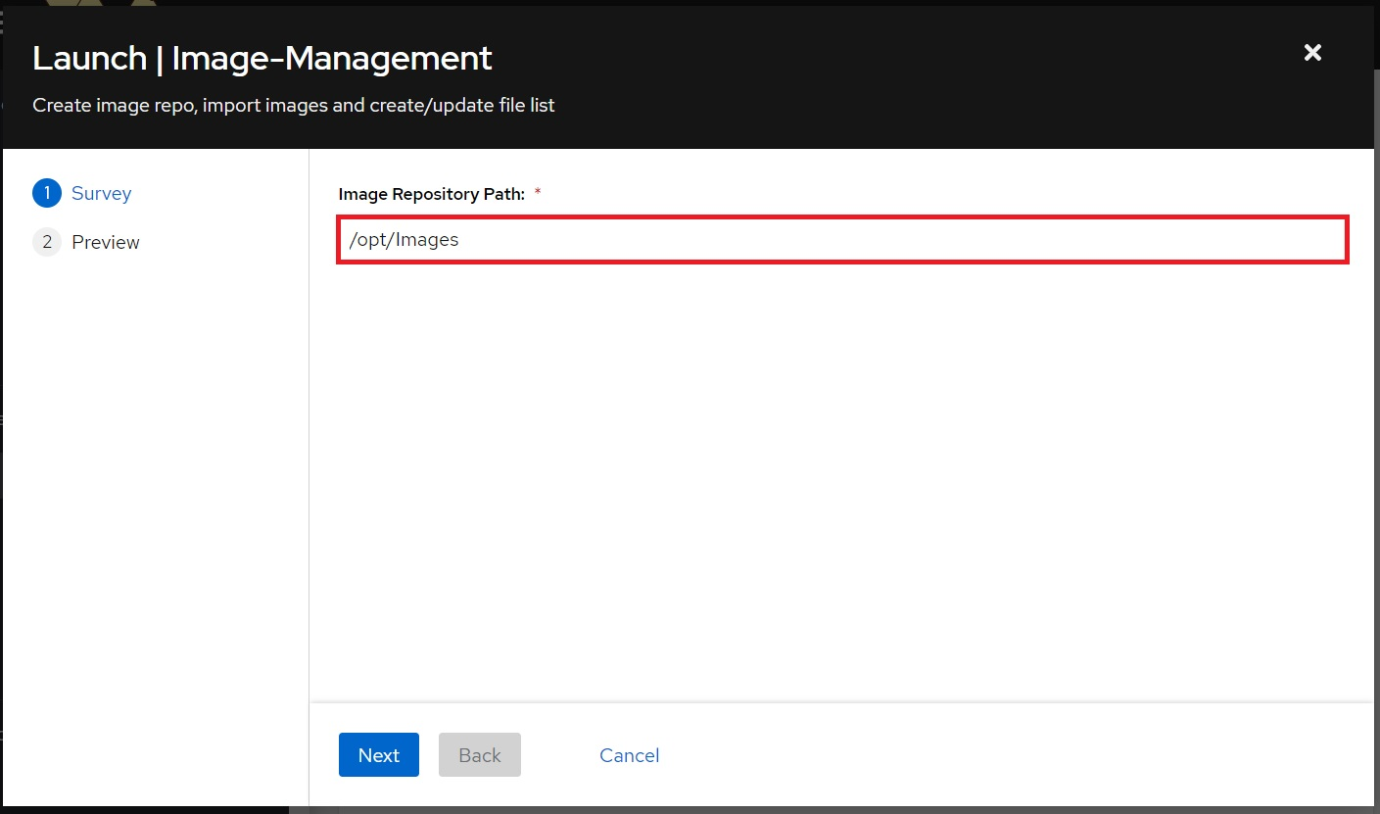

Click **Next** to continue, then click **Launch** on the Preview tab to run the template.

## 7.2 Import images to AWX server

Windows 10 update 1803 includes a native SSH client. Alternatively, the PuTTY suite contains an SCP program: pscp.exe.

From the Windows workstation, copy the boot and application images to the C:\TFTP\ folder:

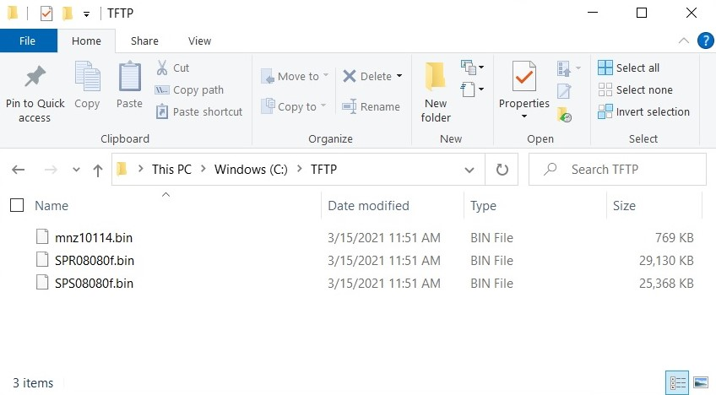

From the Windows workstation, open the command prompt and navigate to the directory with the images. The **dir** command can be executed to verify that the files exist:

|  |
| --- |
| C:\Users\Brian.Stepp>cd c:\TFTP  c:\TFTP>dir  Volume in drive C is Windows  Volume Serial Number is CE9D-669D  Directory of c:\TFTP  03/19/2021 10:25 AM <DIR> .  03/19/2021 10:25 AM <DIR> ..  03/15/2021 11:51 AM 786,944 mnz10114.bin  03/15/2021 11:51 AM 29,829,112 SPR08080f.bin  03/15/2021 11:51 AM 25,976,488 SPS08080f.bin  3 File(s) 56,592,544 bytes  2 Dir(s) 15,008,501,760 bytes free |

To copy the files from the workstation to the AWX server, execute the **scp** command using this syntax:

|  |
| --- |
| scp <source> <username>@<destination_ip>:<destination_path> |

Command breakdown:

* **source:** Local path to the file that is to be copied. *.bin can be used to copy all .bin files.
* **username:** Username used to login to the AWX server.
* **destination_ip:** IP or hostname of the AWX server.
* **destination_path:** Path to the destination directory for the image files.

For example:

|  |
| --- |
| c:\TFTP>scp .\*.bin awxuser@192.168.1.13:/opt/Images/  awxuser@192.168.1.13's password:  SPR08080f.bin 100% 28MB 42.2MB/s 00:00  SPS08080f.bin 100% 25MB 43.9MB/s 00:00  mnz10114.bin 100% 769KB 133.6MB/s 00:00  c:\TFTP> |

When the files have been copied to the image repo directory, the "*Image-Management*" template will need to be run in order to generate the “*Image-Flash-Copy-File* and *Image-Flash-Copy-Version* templates.

Click the **Templates** button from the left navigation bar, then click the launch button next to "*Image-Management*":

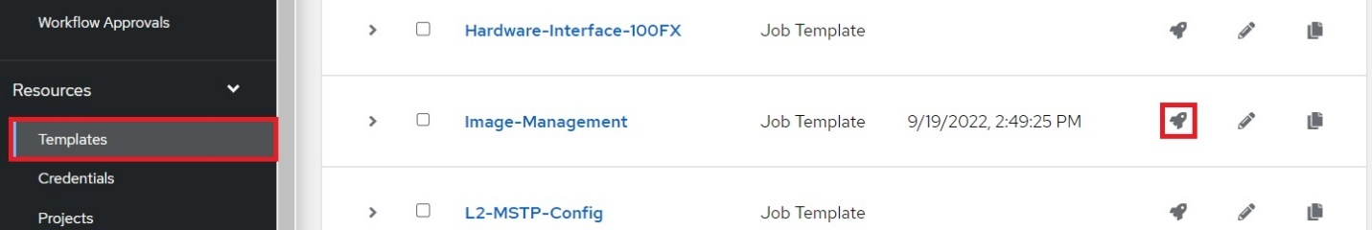

Complete the following field:

**Image Repository Path:** Ensure this matches the full path of the image repository.



Click **Next** to continue, then click **Launch** on the Preview tab to run the template.

## 7.3 View Image Repository Files

Click the **Hosts** button from the left navigation bar, then click the AWX server host:

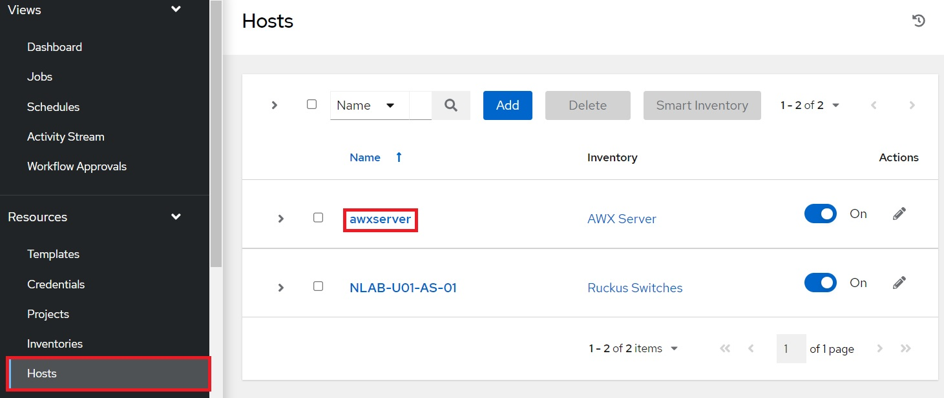

From the AWX server host page, click the **Facts** tab, click on **YAML** then click the **Expand** button:

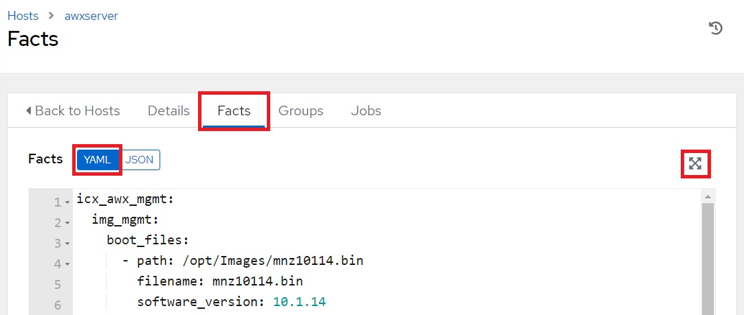

An expanded facts window will appear.

The software image files will be listed under the icx_awx_mgmt.img_mgmt.image_files variable:

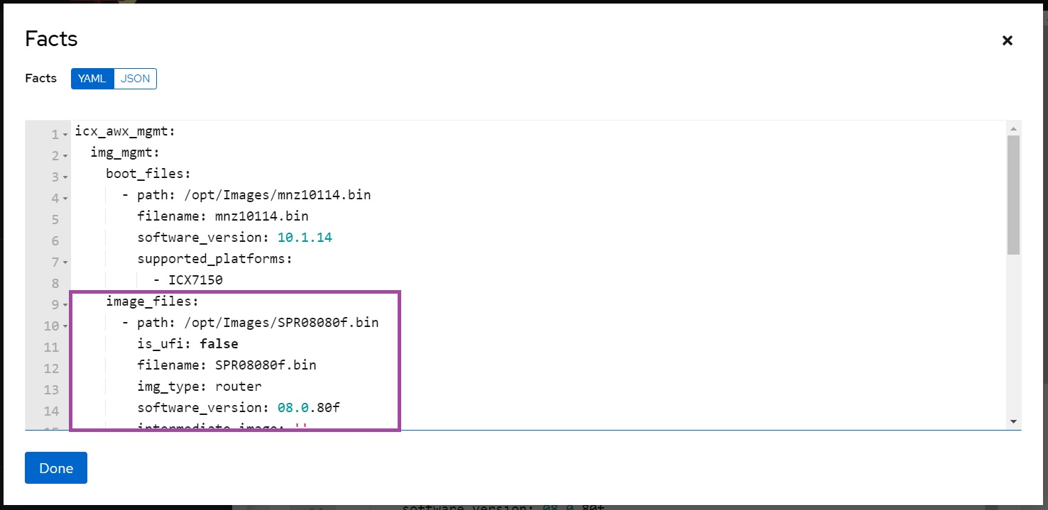

The boot image files will be listed under the icx_awx_mgmt.img_mgmt.boot_files variable:

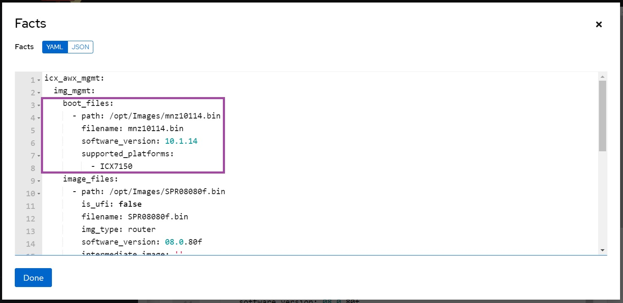

## 7.4 Copy image files to switch flash

Running "*Image-Management*" will create the "*Image-Flash-Copy-File*" and "*Image-Flash-Copy-Version*"templates when valid images exist in the image repository. The survey prompt in the "*Image-Flash-Copy-File*" template contains a list of valid images and the survey prompt in the "*Image-Flash-Copy-Version*" template contains a list of version numbers. These lists are updated every time the "*Image-Management*" template is run.

### 7.4.1 Switch software upgrade by filename

This software upgrade method will use the "*Image-Flash-Copy-File*" template which prompts for a specific filename to copy to the switch. This method is limited by only being able to update switches in an AWX inventory that are compatible with the specific image file that is selected.

First click the **Templates** button from the left navigation bar, then click the launch button next to "*Image-Flash-Copy-File*":

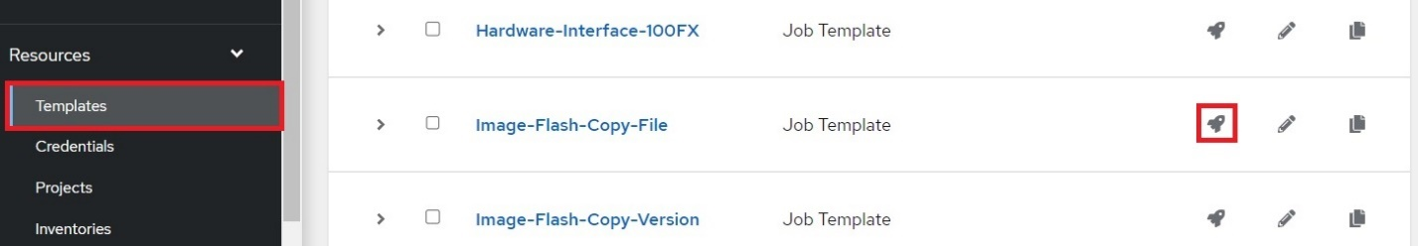

Select the inventory containing the switch hosts, then click **Next**:

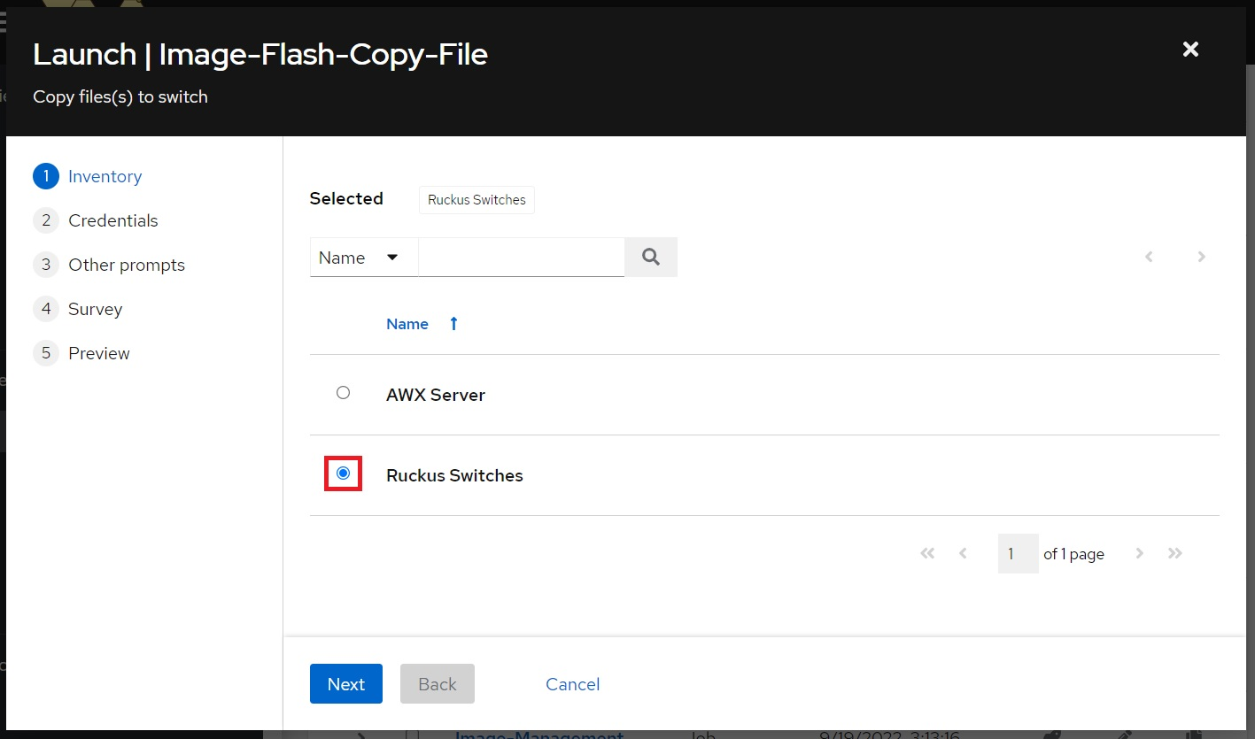

Select the switch login credentials, then click **Next**:

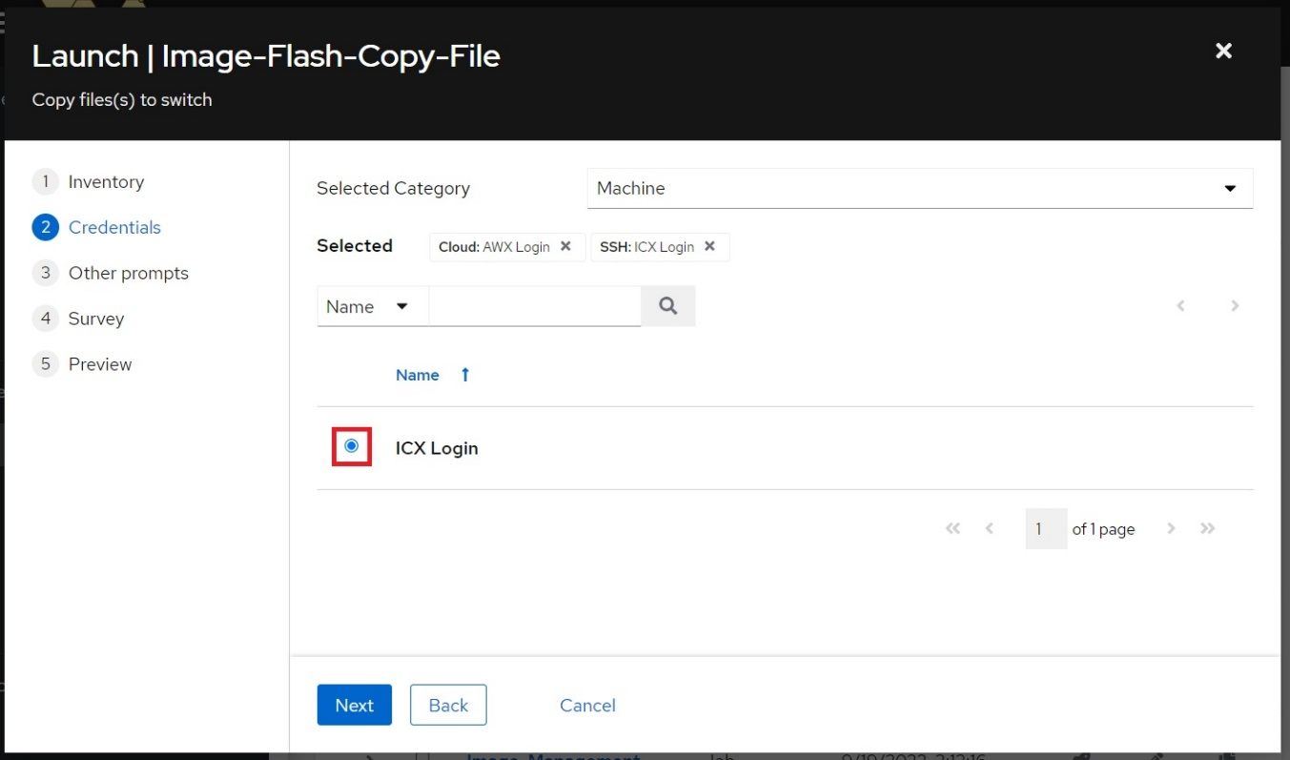

Note that the AWX server login credentials have been automatically added to the template. As the playbook needs to shell into the AWX server to push the image to the switch, these credentials are necessary.

The Limit prompt can limit the execution of the template to a single host in an inventory. If left blank, the template will run against all hosts in the inventory. The host's name can be entered into the prompt to limit execution to that host:

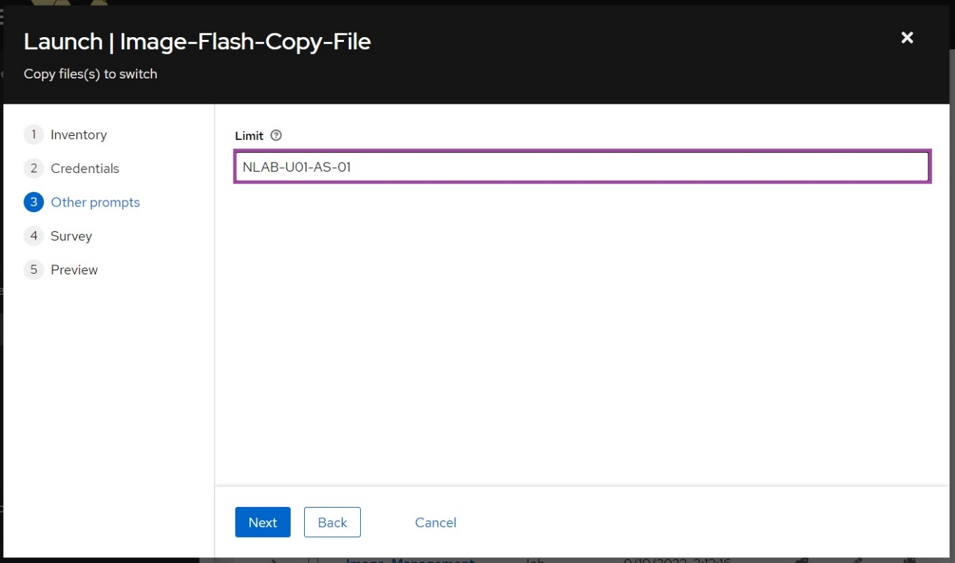

Click **Next** to continue.

In the Survey prompt, complete the following fields:

**FastIron Image File**: Select the application image from the drop-down menu.

**Boot Image File**: Selecting **Auto Select** will attempt to match the targeted switch model and application version to an installed boot image. Selecting **None** skips copying of boot image. Selecting a boot image from the list attempts to force installation of that boot image.

**Flash Partition**: Select the partition on the switch to copy the image to.

**Configure Selected Flash Partition as First in Boot Order?**: Select **Yes** to ensure selected flash partition has priority during boot.

**Reboot Into New Image After Deployment?**: Select **Yes** to perform a boot into the selected boot partition of the switch after the image(s) have been copied.

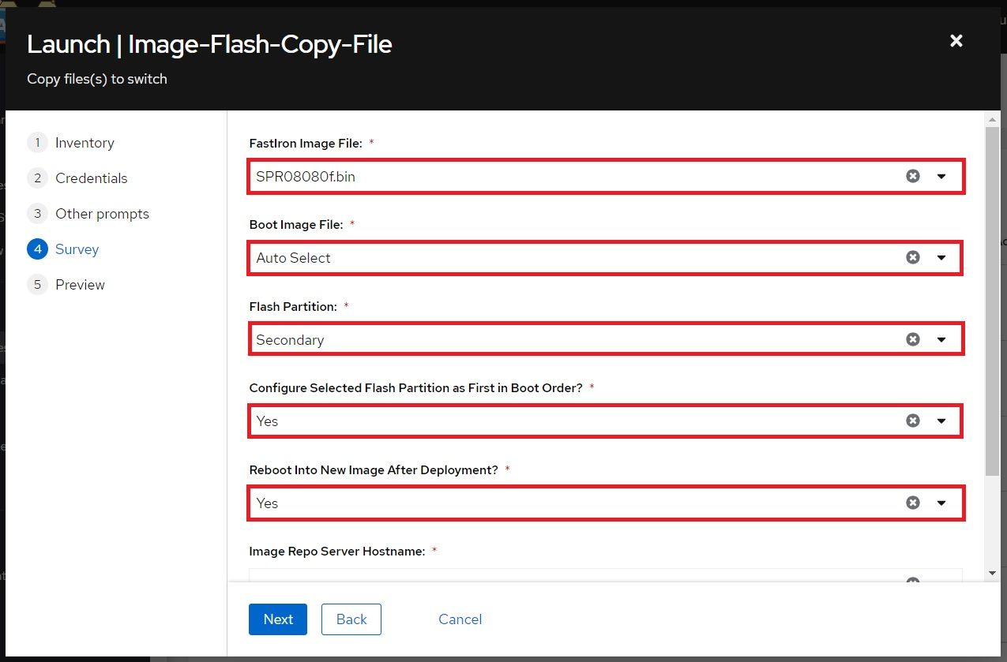

Note: The bottom two entries, **Image Repo Server Hostname** and **SCP Server Address** should not be changed and are used to pass required information to the playbook.

When finished, click **Next**, then click **Launch** on the Preview tab to run the template.

### 7.4.2 Switch software upgrade by version

This software upgrade method will use the "*Image-Flash-Copy-Version*" template which prompts for a software version and image type. When the template is launched, each switch in the inventory will be queried to get the model number which will be used along with the software version and image type to select a compatible image file. This method can be used to update all switches in an AWX inventory to a specific version regardless of model if the appropriate images are in the image repository.

First click the **Templates** button from the left navigation bar, then click the launch button next to "*Image-Flash-Copy-Version*":

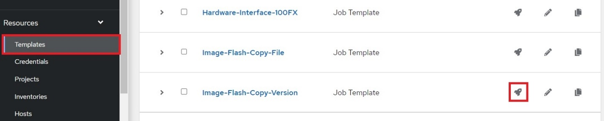

Select the inventory containing the switch hosts, then click **Next**:

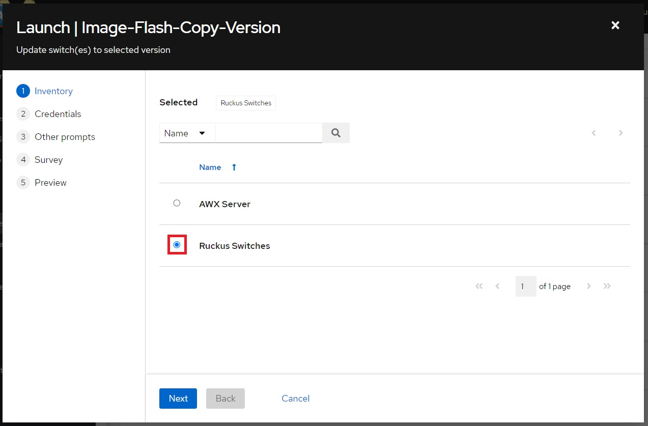

Select the switch login credentials, then click **Next**:

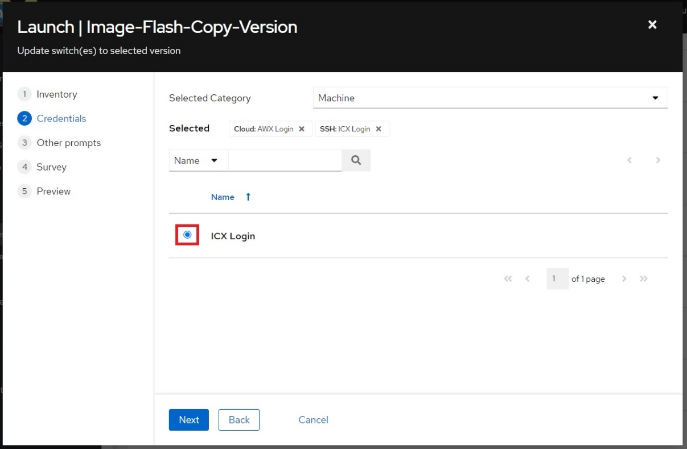

Note that the AWX server login credentials have been automatically added to the template. As the playbook needs to shell into the AWX server to push the image to the switch, these credentials are necessary.

The Limit prompt can limit the execution of the template to a single host in an inventory. The host's name can be entered into the prompt to limit execution to that host. If left blank, the template will run against all hosts in the inventory:

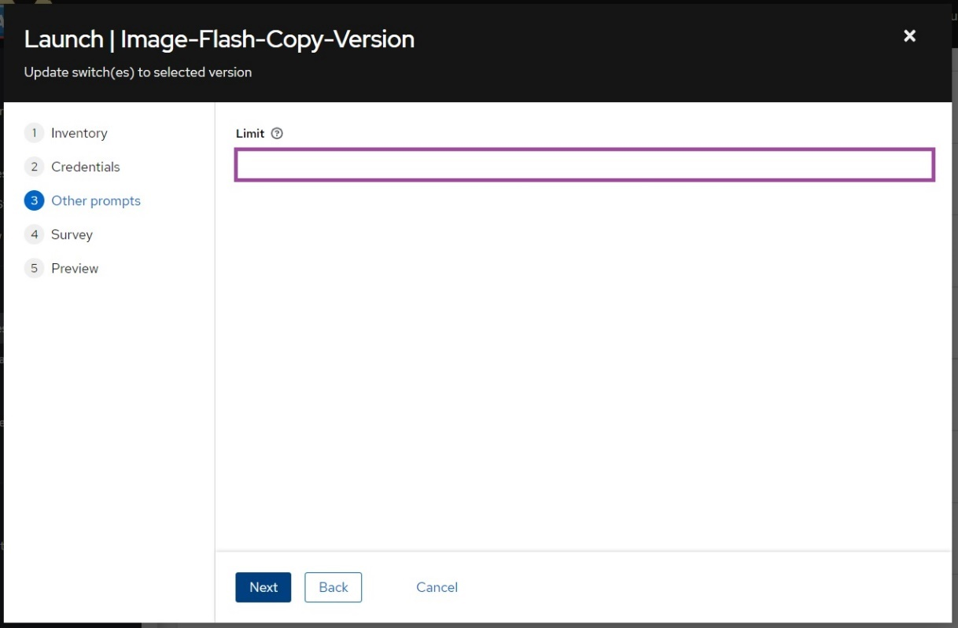

Click **Next** to continue.

In the Survey prompt, complete the following fields:

**FastIron Version**: Select the software version from the drop-down menu.

**FastIron Image Type**: Select whether to install the switch or router type of software image.

**Boot Image Selection Method**: Selecting **Auto Select** will attempt to match the targeted switch model and application version to an installed boot image. Selecting **None** skips copying of boot image.

**Flash Partition**: Select the partition on the switch to copy the image to.

**Configure Selected Flash Partition as First in Boot Order?**: Select **Yes** to ensure selected flash partition has priority during boot.

**Reboot Into New Image After Deployment?**: Select **Yes** to perform a boot into the selected boot partition of the switch after the image(s) have been copied.

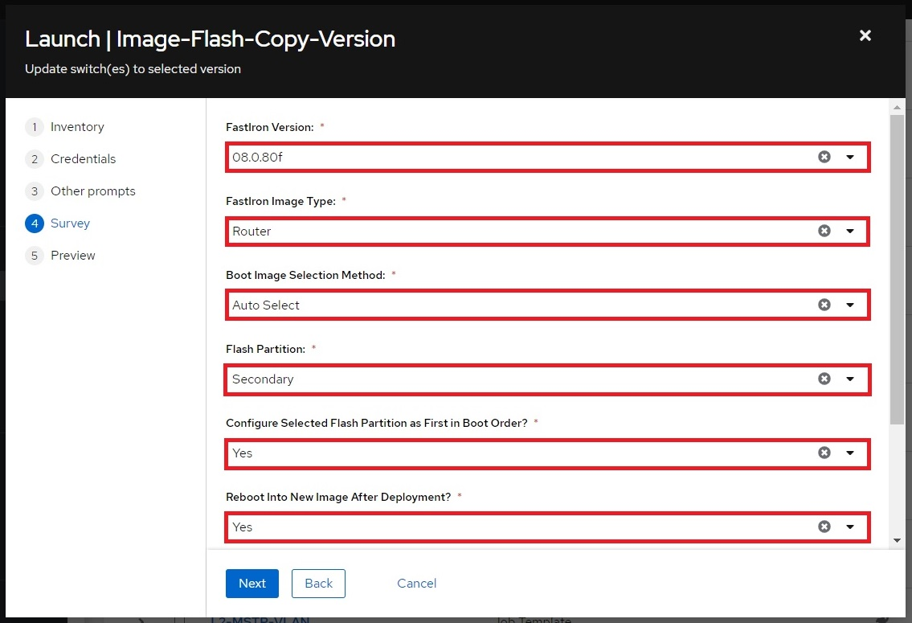

Note: The bottom two entries, **Image Repo Server Hostname** and **SCP Server Address** should not be changed and are used to pass required information to the playbook.

When finished, click **Next**, then click **Launch** on the Preview tab to run the template.

# 8. Setup AWX-ZTP

Zero-Touch Provisioning (ZTP) is a feature that allows for automatic provisioning and configuration of network devices when they come online. The *awx_management* role contains the *ztp_management* sub-role which utilizes AWX to provide zero-touch provisioning of Ruckus ICX switches.

## 8.1 Launch "ZTP-Configure"

The "*ZTP-Management*" template can perform several tasks including:

Installs “*ISC-DHCP-Server*”.

Configures a secondary interface on the AWX server with an IP address.

Creates a provisioning inventory in AWX. Hosts discovered by DHCP are placed here.

Configures DHCP on the AWX server.

Creates an IP pool for configuring a static IP address on a host interface.

Creates a hostname pool to configure a hostname on a host.

The following provides a guide for running the "*ZTP-Configure*" template.

From the **Templates** page, click the launch button next to "*ZTP-Managment*":

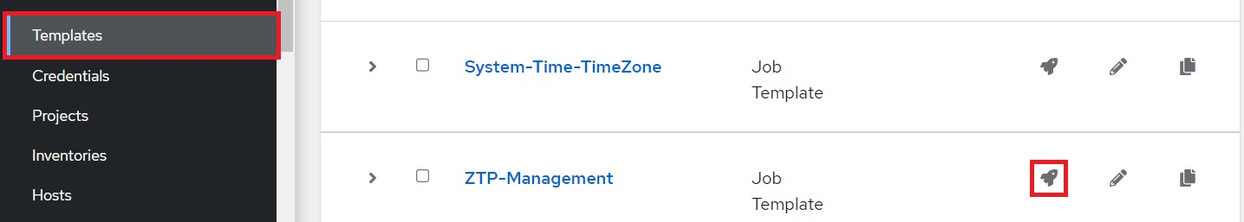

Complete the following fields:

**Provisioning Inventory**:Name of ZTP Inventory to create.

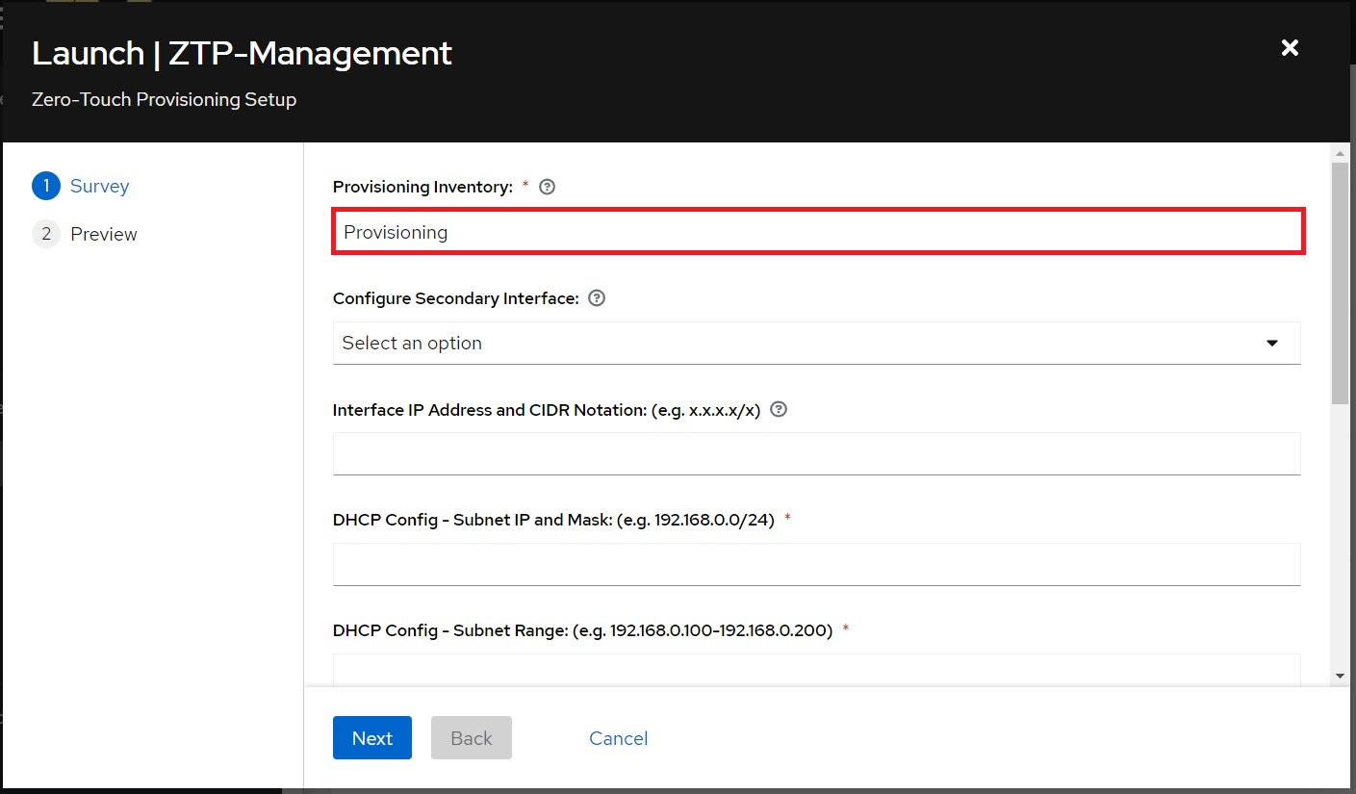

Note: The prompt to configure a secondary interface will only be visible on a system that uses Netplan for network management and if more than one ethernet interface is present.

To optionally configure a secondary interface, complete the following fields:

**Configure Secondary Interface**: Select the interface configure a static IP address on.

**Interface IP Address and CIDR Notation**: Enter the IP address and mask to assign to the interface.

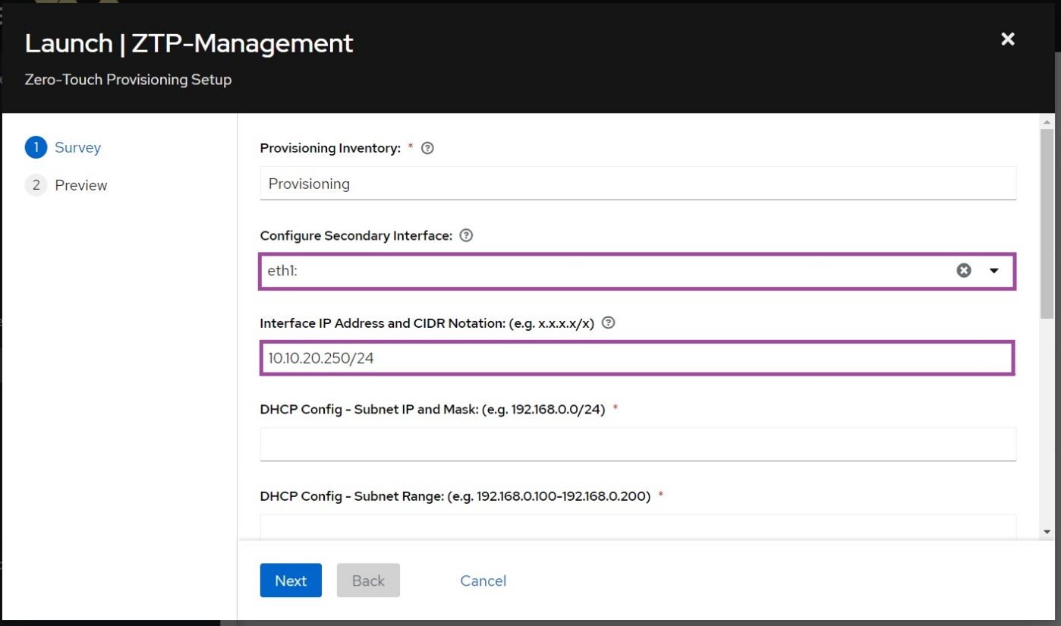

Complete the following DHCP configuration fields:

**Subnet IP and Mask**: Enter the DHCP subnet prefix and mask.

**Subnet Range**:Enter the IP range to be used as the DHCP allocation pool.

**Default Router**: (Optional) Enter the default gateway to be assigned to the switch.

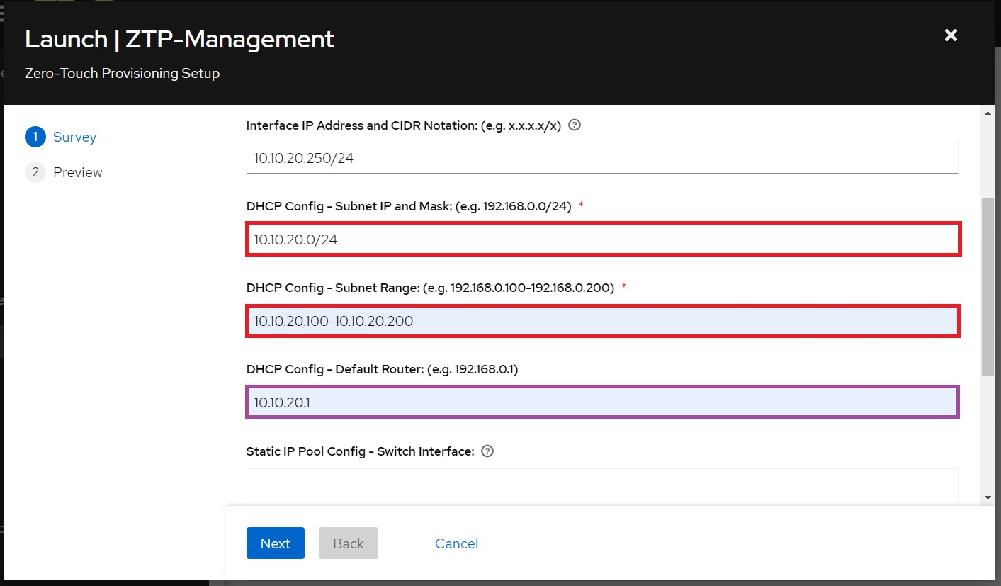

To optionally configure a static IP address pool, complete the following fields:

**Switch Interface:**  Interface on switch where static IP will be configured.

**Subnet:** Enter the prefix and mask of static IP pool network.

**IP Range:** Enter the IP range to be used to allocate static IP addresses.

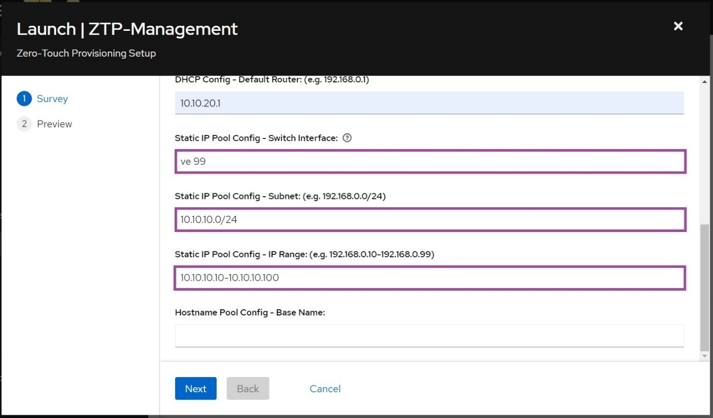

To optionally configure a hostname pool, complete the following field:

**Base Name**:Enter the base name to be used for hostname allocation. 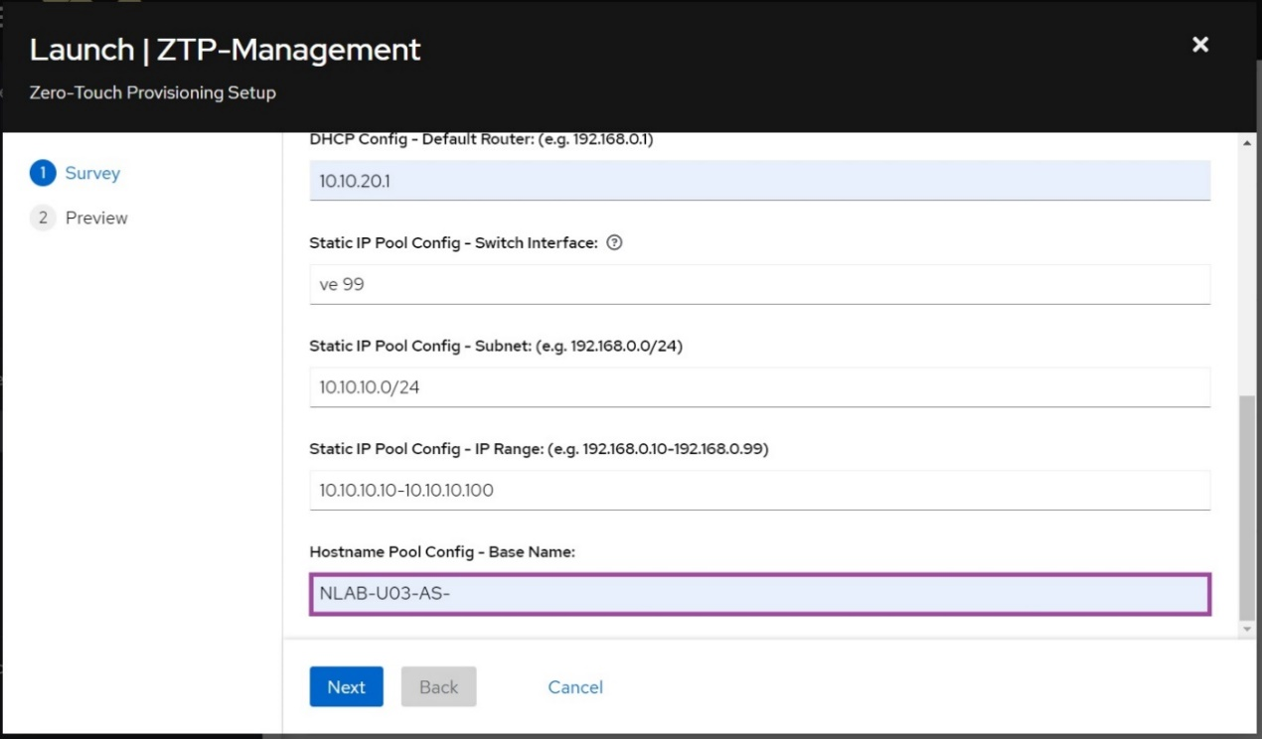

Click **Next** when finished, then click **Launch**.

Notes:

* When the template has successfully completed, the DHCP server will start listening for hosts.
* Up to four templates will be generated the first time the template has run:

***ZTP-Regen-Token***: Regenerates the authentication token used by the DHCP webhook.

***ZTP-Configure-Server-Address***: Configures AWX interface with static IP address. Can also configure a static route for the interface.

***Provisioning-Init-Login***: Called directly by the DHCP webhook. Performs initial switch setup to allow access by AWX.

***Provisioning-Finalize***: Handles the assignment of static IP addresses from the pool as well as the assignment of hostnames. Usage covered by the *Workflow Creation* section below.

## 8.2 Workflow Creation

A workflow created in AWX can be automatically launched by the "*Provisioning-Init-Login*" template. The following provides an example of creating a workflow.

Click **Templates** from the left navigation bar. Then click the **Add** button and select **Add workflow template**:

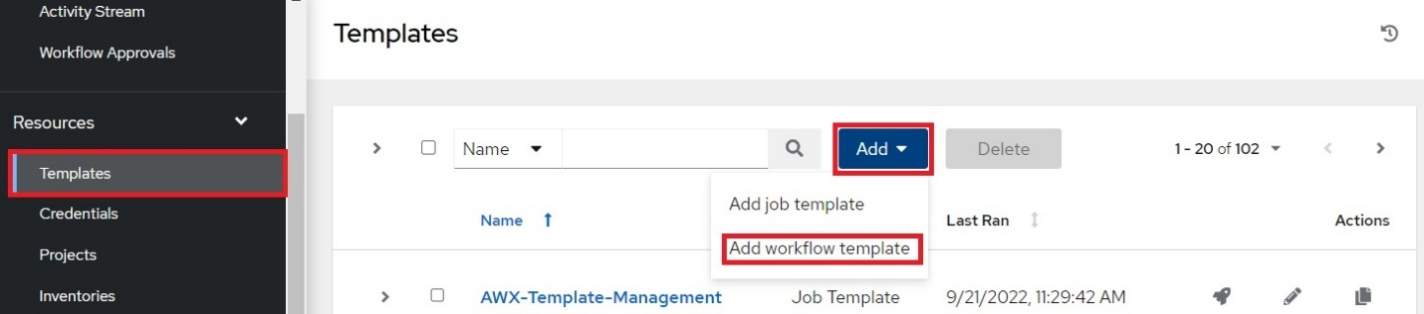

The **Create New Workflow Template** page will display. Complete the following fields:

**Name**: Type in a name for the workflow.

**Limit**: Click the checkbox next to **Prompt on launch.** This is necessary to run the workflow against a single host.

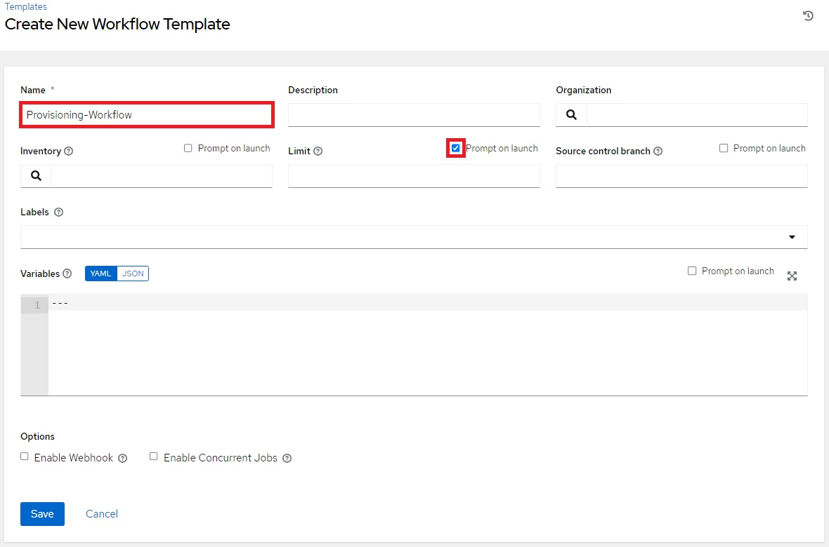

When finished, click **Save**.

The **Workflow Visualizer** will open. Click the **Start** button:

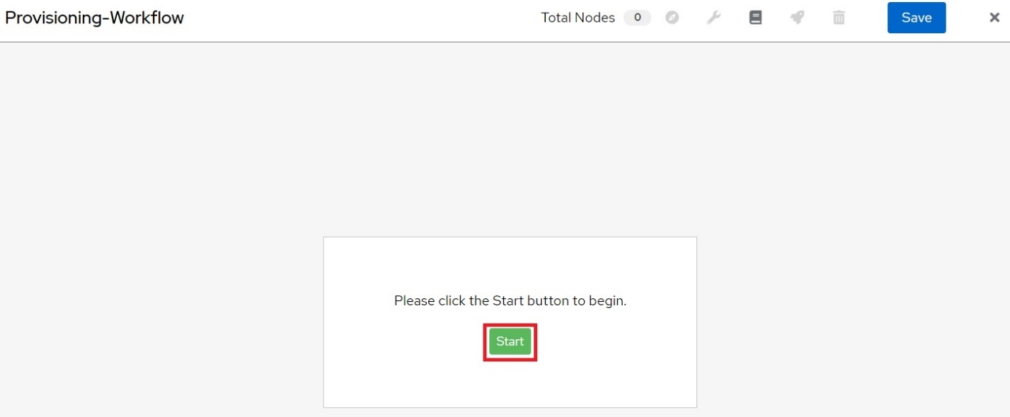

The list of templates will appear. The templates can be added to a workflow here. For this example, select the **Remote-User-LocalAcct** template, then click **Next**:

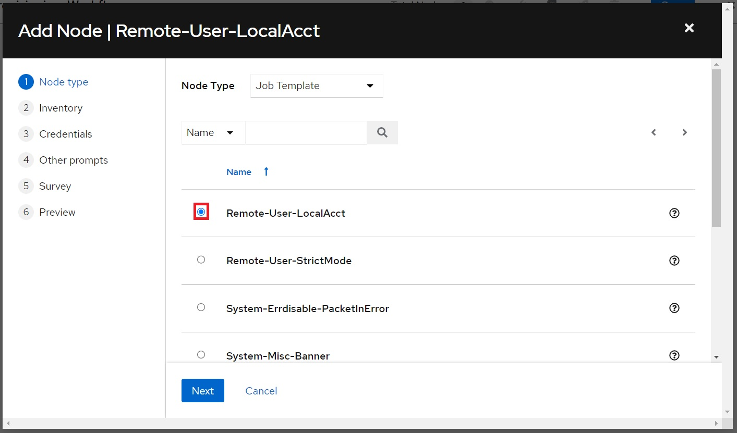

Select the name of the provisioning inventory, then click **Next**:

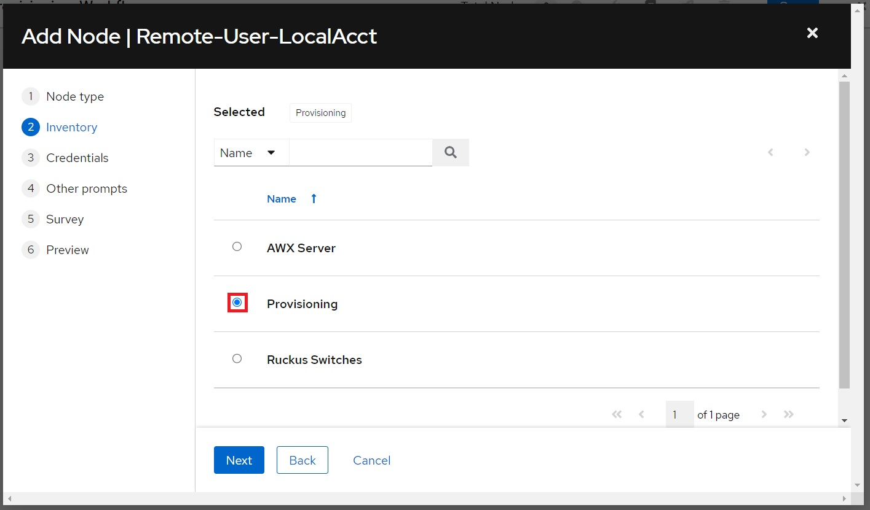

Select the **ZTP_Default_Login** credentials, then click **Next**:

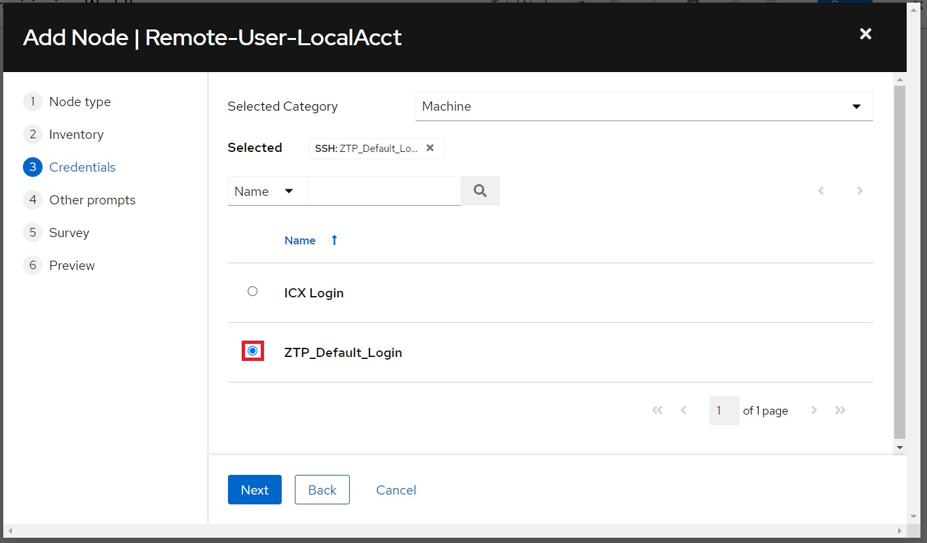

Leave the **Limit** prompt blank. Click **Next**:

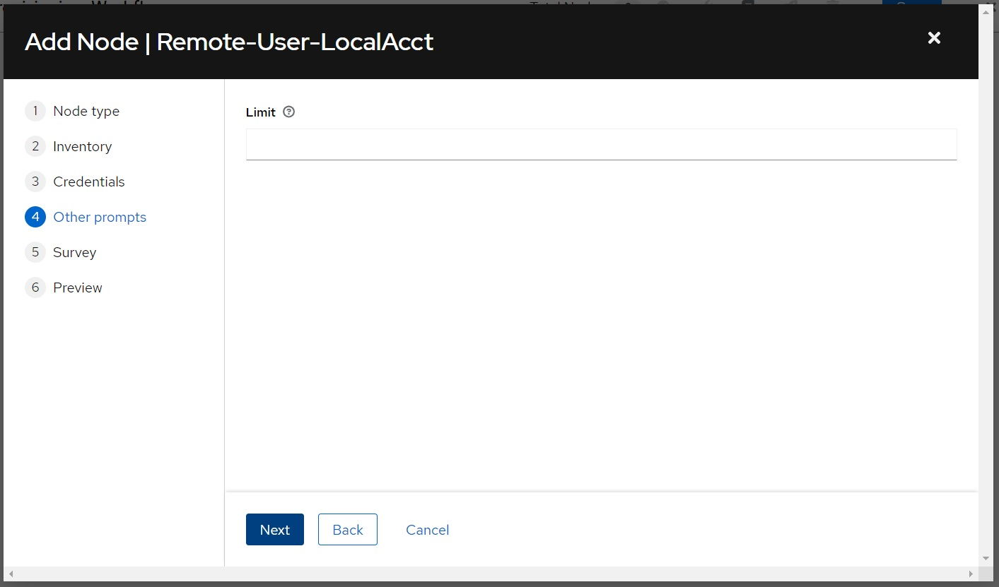

Type in a username and password to add as a local account on the switch, then click **Next**:

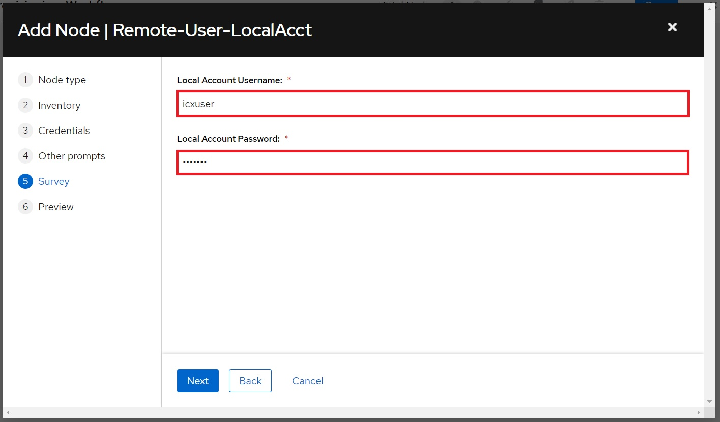

Click **Save**:

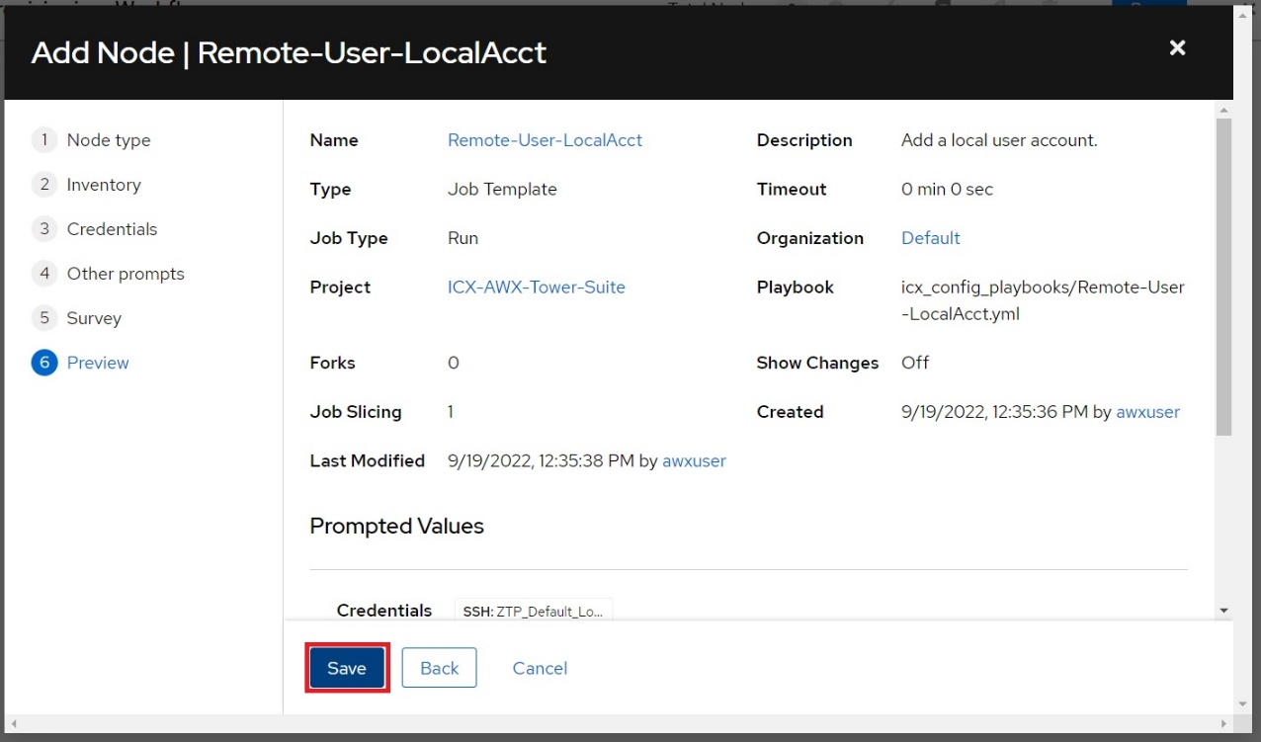

Mouse over the last node, then click the **+** button to add the next node:

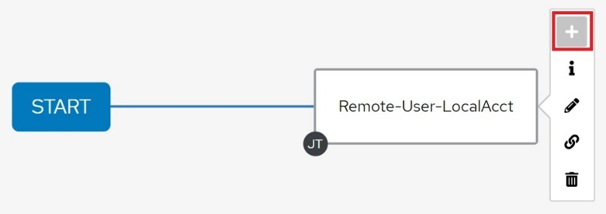

Ensure **On Success** is selected, then click **Next**:

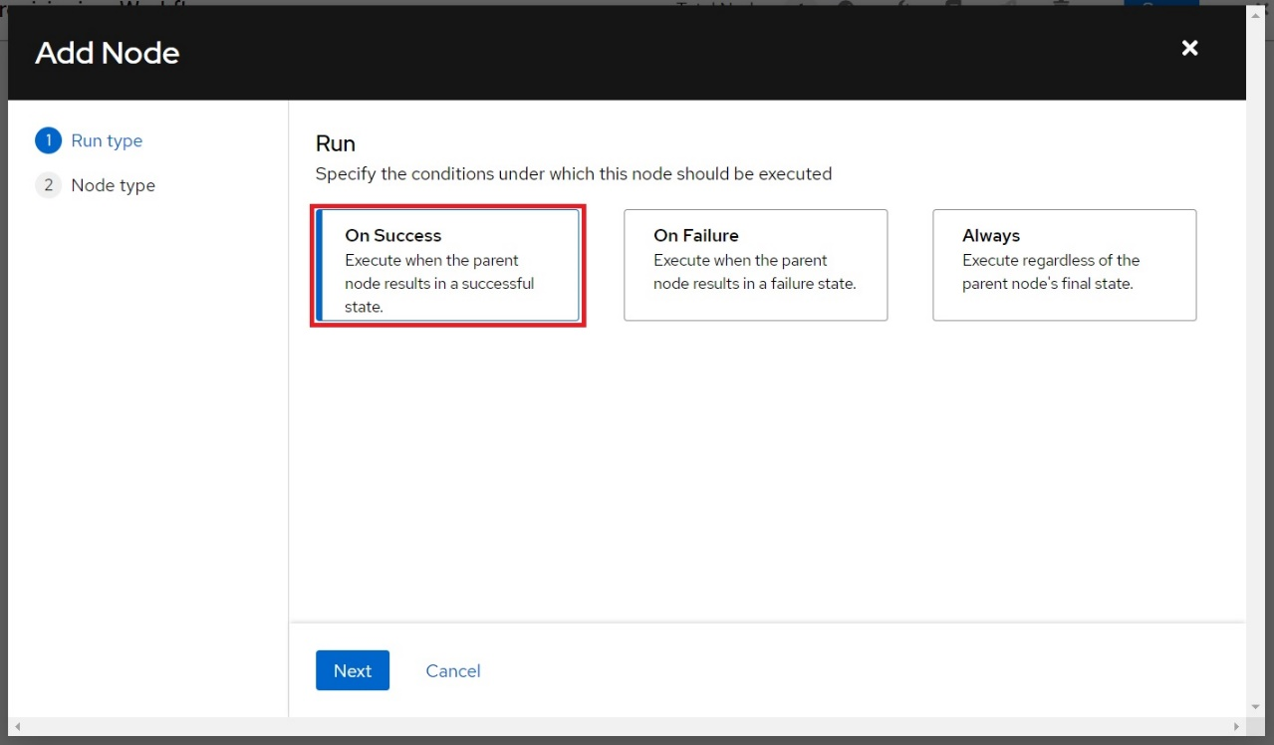

In the example for the ZTP-Management template run, VE 99 was used for the static IP configuration. This will need to be created before the static IP address can be configured.

Select the “*L2-VLAN-Config*” template, then click **Next**:

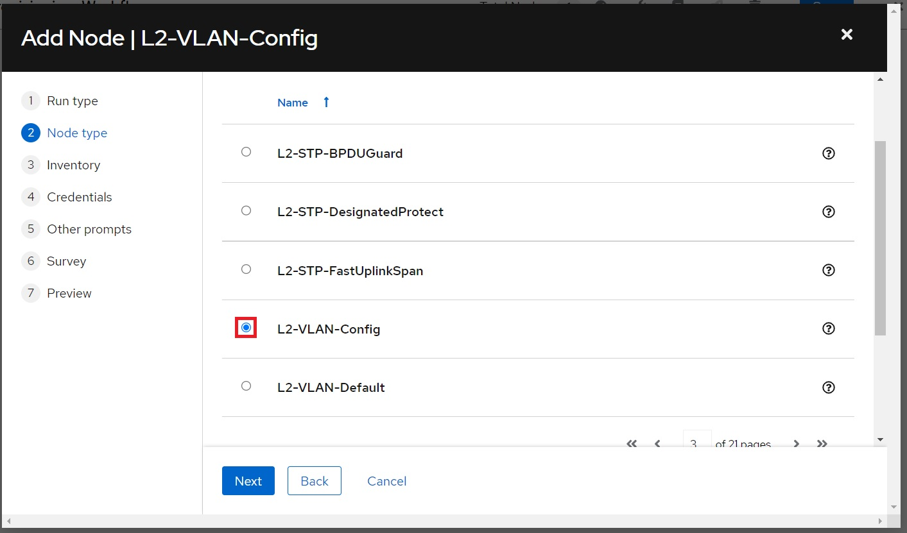

Select the name of the provisioning inventory, then click **Next**:

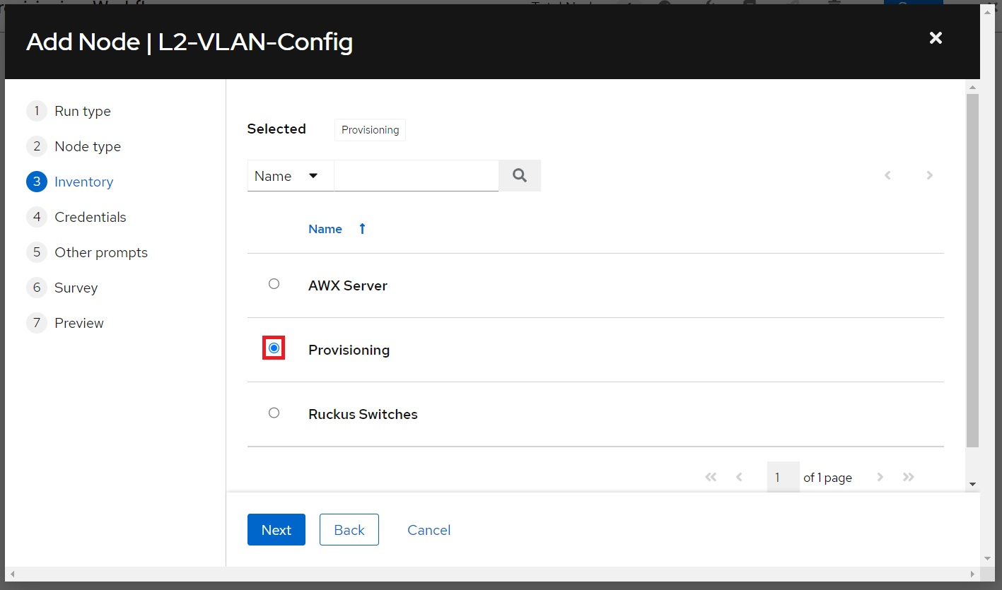

If the login credentials configured for the job in the previous step match the credentials that are saved in AWX, they can now be selected:

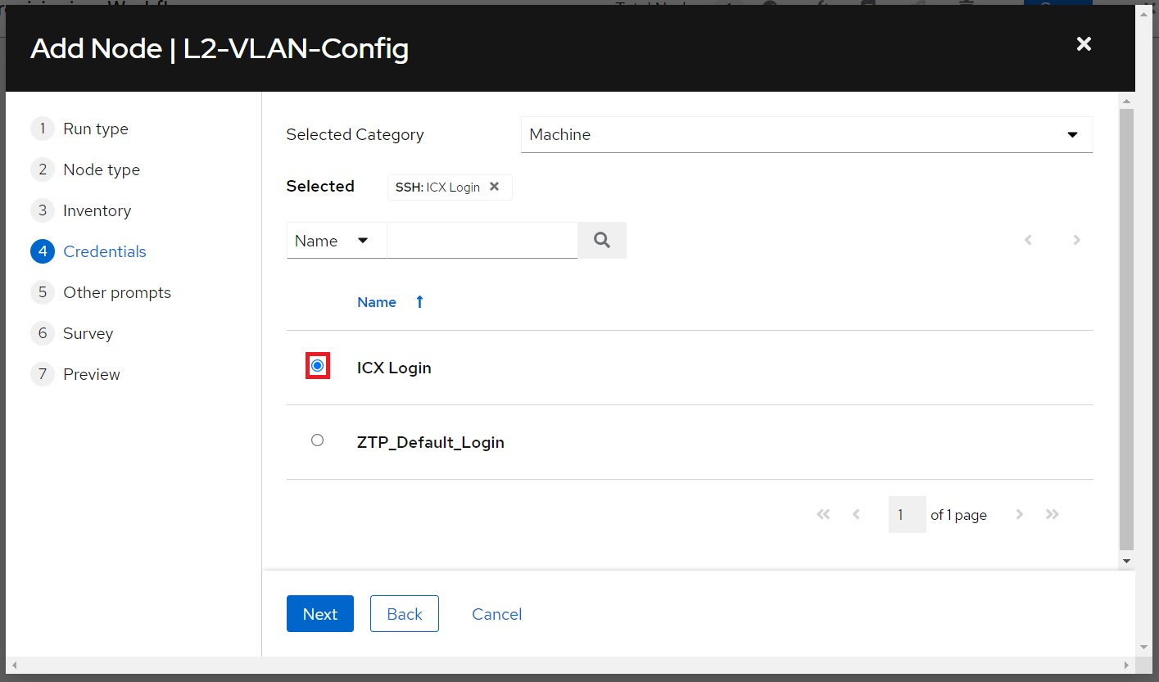

Click **Next** when finished.

Leave the **Limit** prompt blank. Click **Next**:

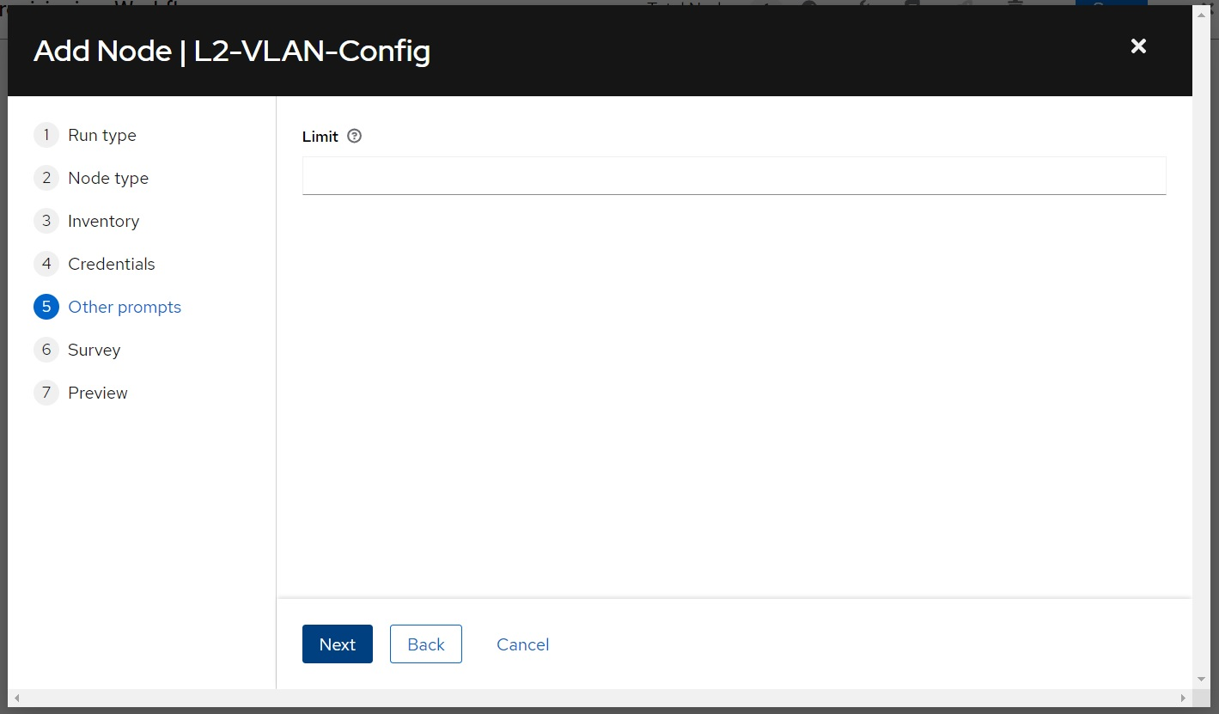

Complete the Survey prompt on the next page, then click **Next.**

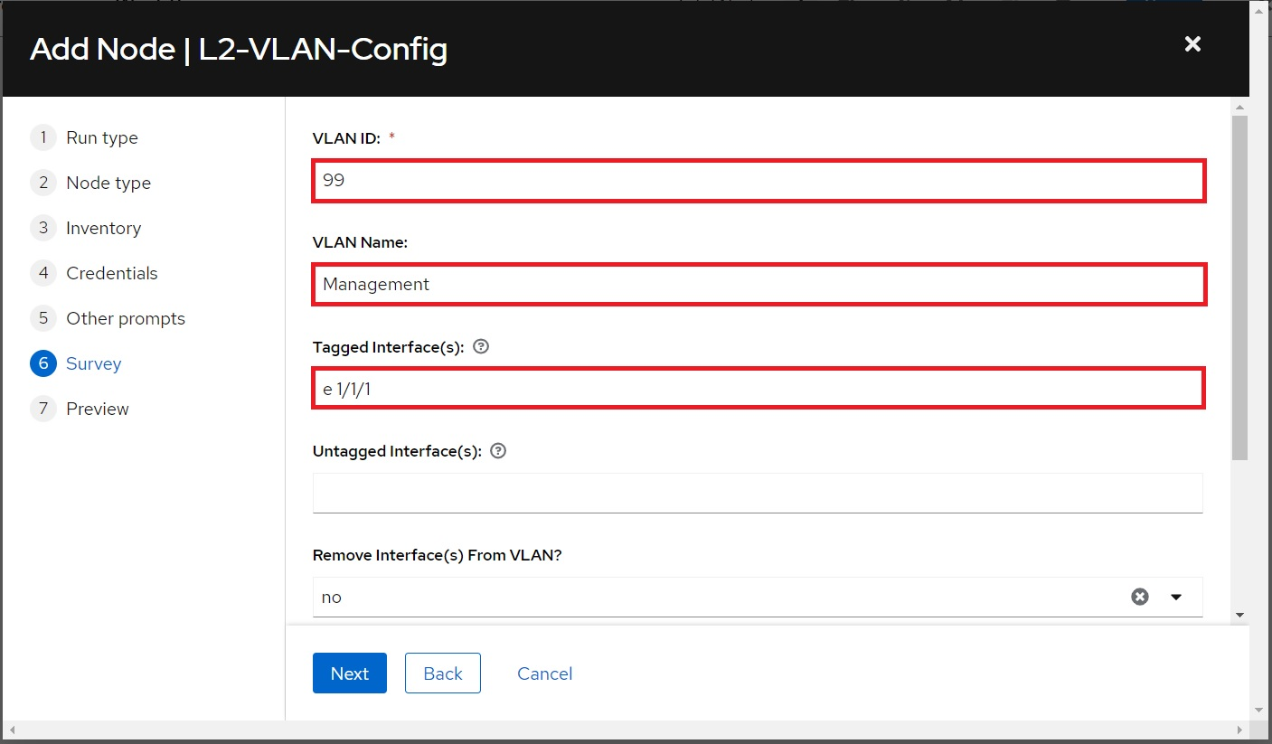

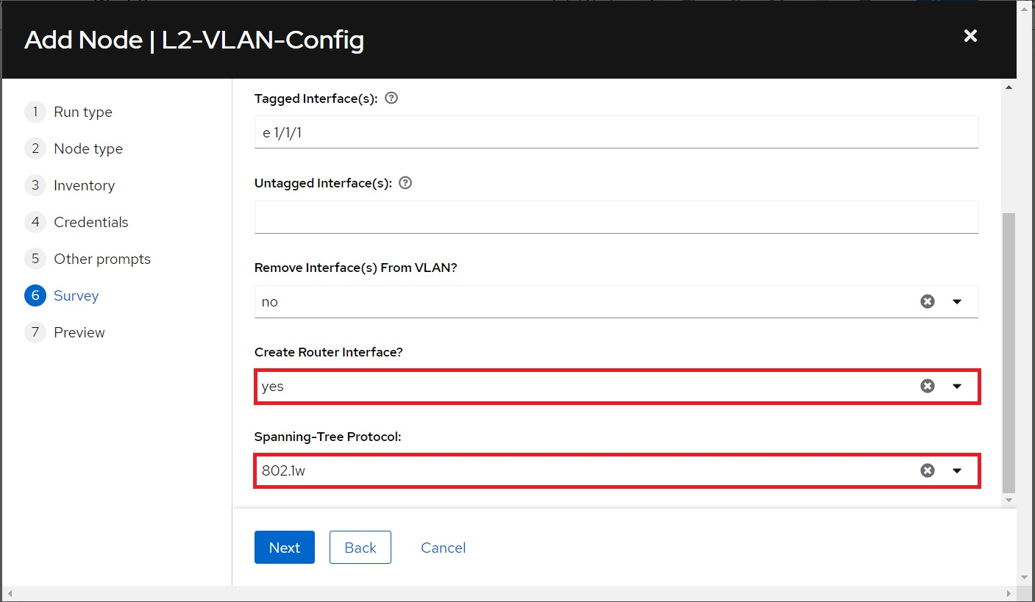

Click **Save**:

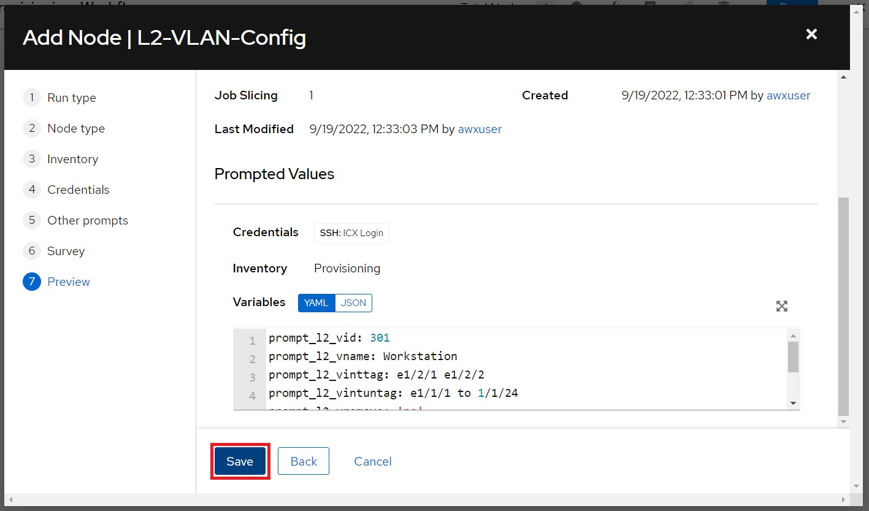

Other templates can be added to the workflow to build out a baseline configuration. Other workflows can also be added to a workflow. The last template to add to the provisioning workflow should be the "*Provisioning-Finalize*" template. This template will configure a static IP address and hostname onto the switch.

To add the "*Provisioning-Finalize*" template to the workflow, mouse over the last node, then click the **+** button:

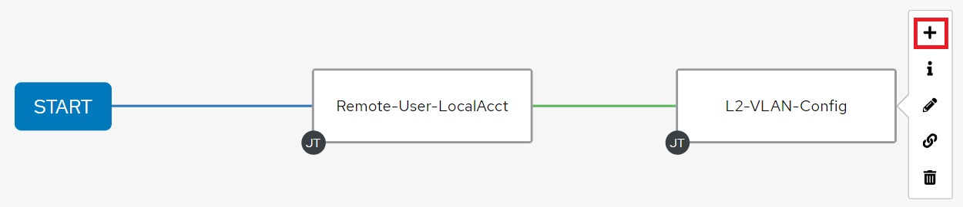

Ensure **On Success** is selected, then click **Next**:

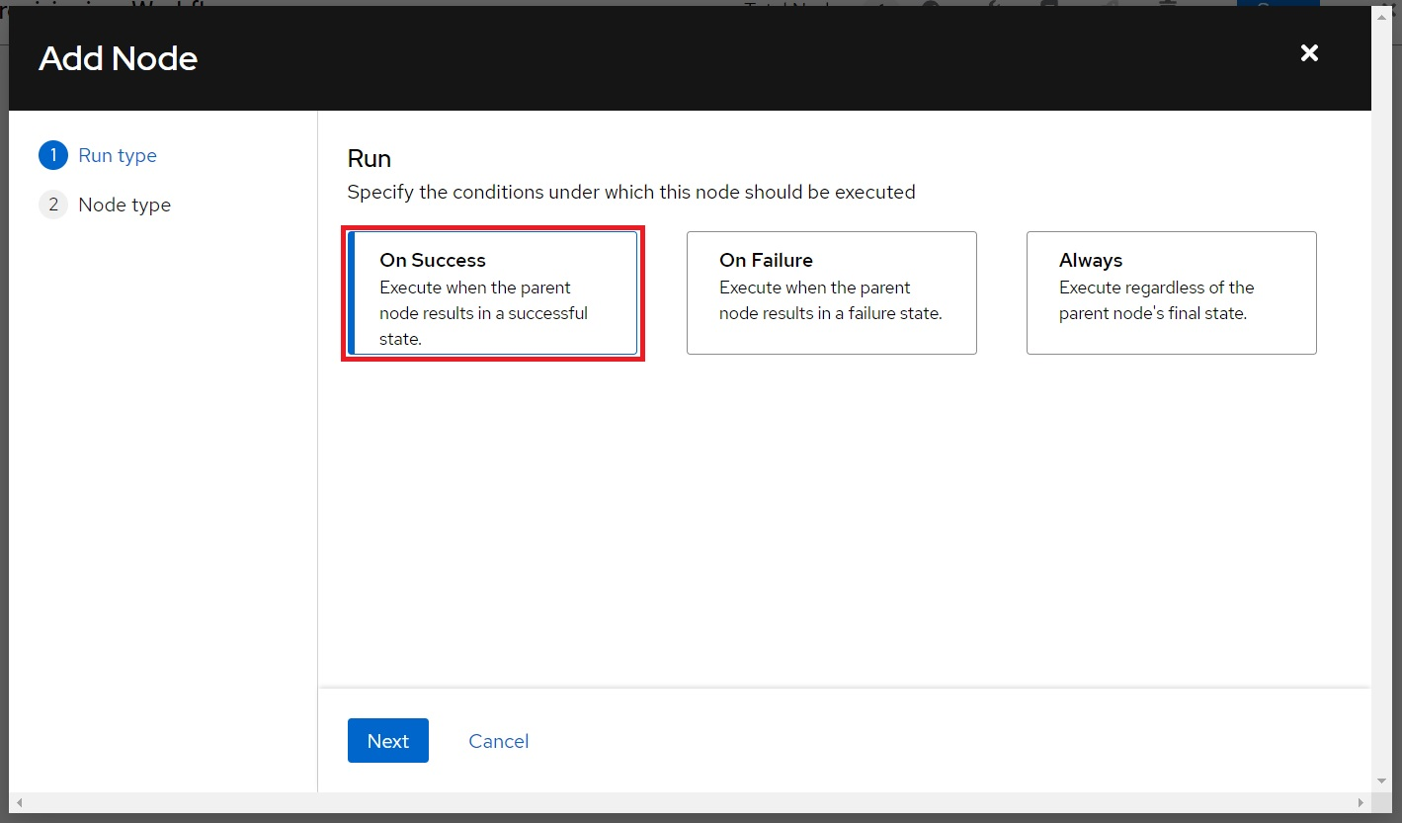

Select “*Provisioning-Finalize*”, then click **Next**:

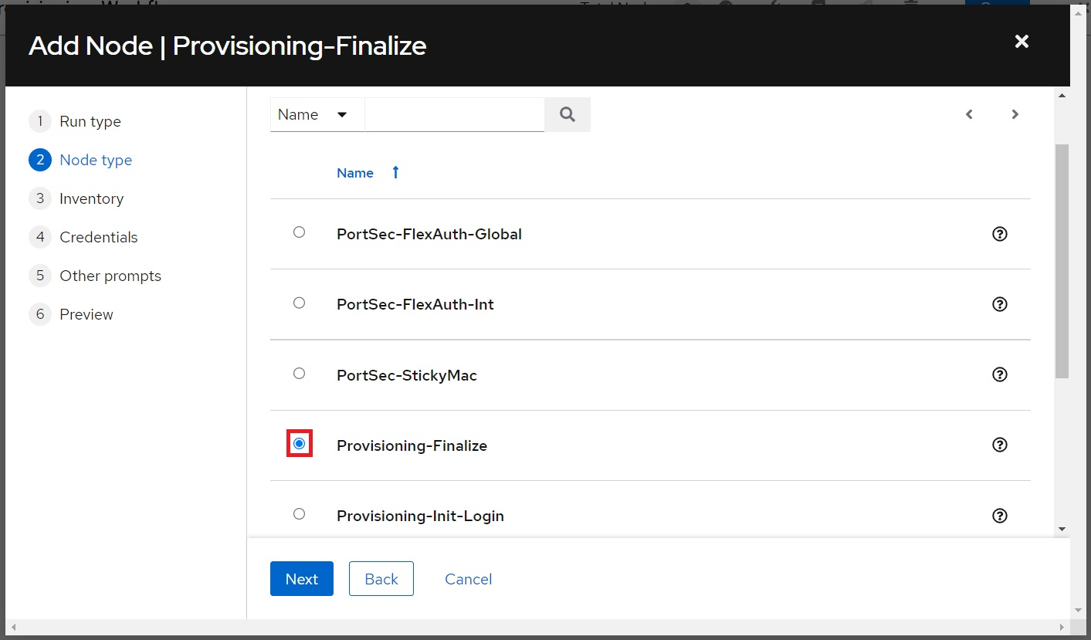

Select the name of the provisioning inventory, then click **Next**:

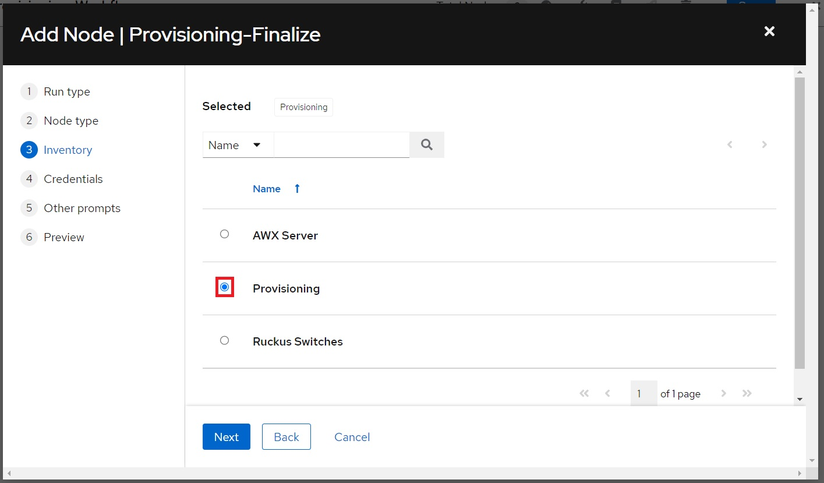

The "*Provisioning-Finalize*" template requires two set of credentials, the switch login credentials and the AWX login credentials which should be automatically added to the template. Select the switch login credentials, then click **Next**:

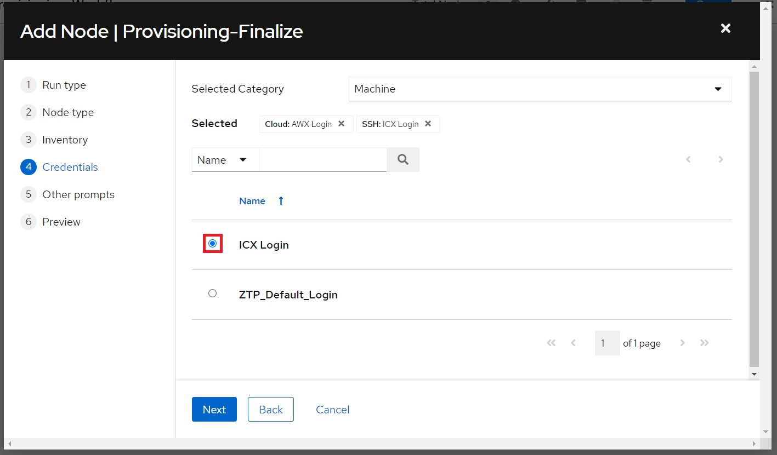

Leave the **Limit** prompt blank, then click **Next:**

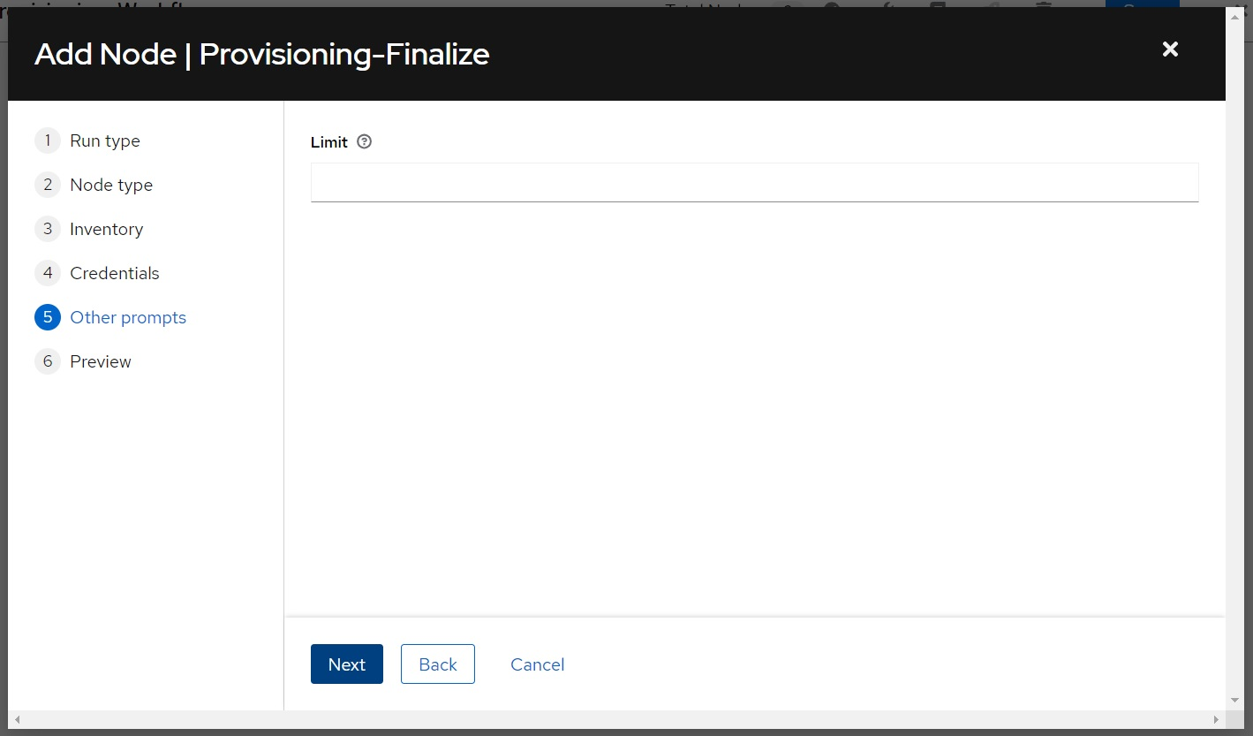

Click **Save**:

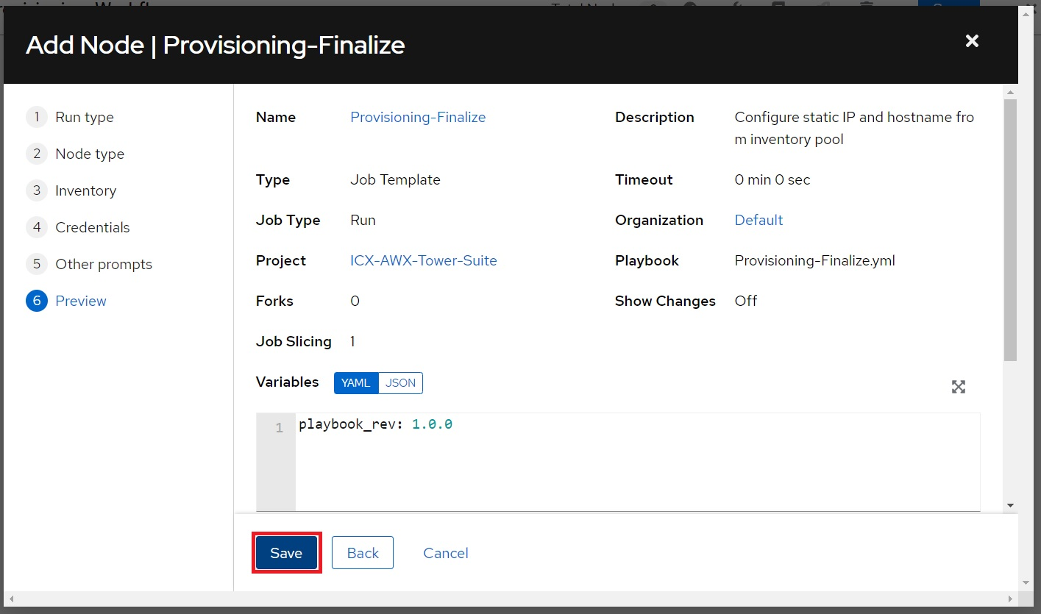

Click **Save** to save the workflow:

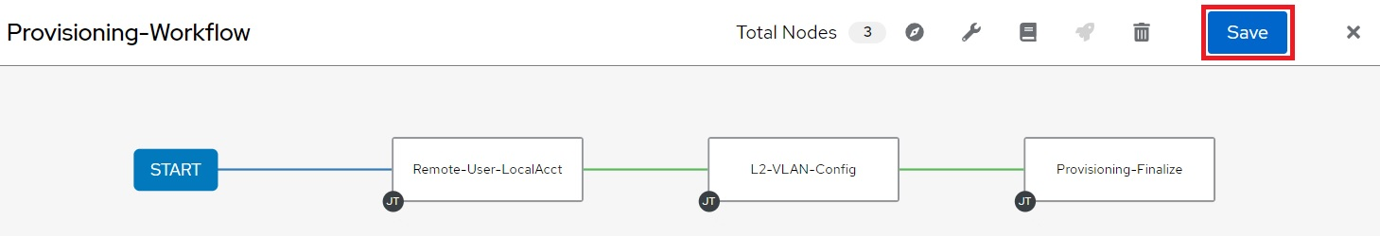

## 8.3 Adding Workflow to ZTP

Now that the workflow is created, it can be added to ZTP.

Click **Inventories** from the left navigation bar, the select the provisioning inventory:

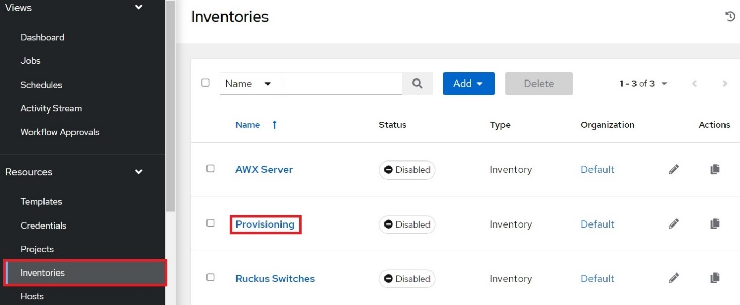

Click **Edit**:

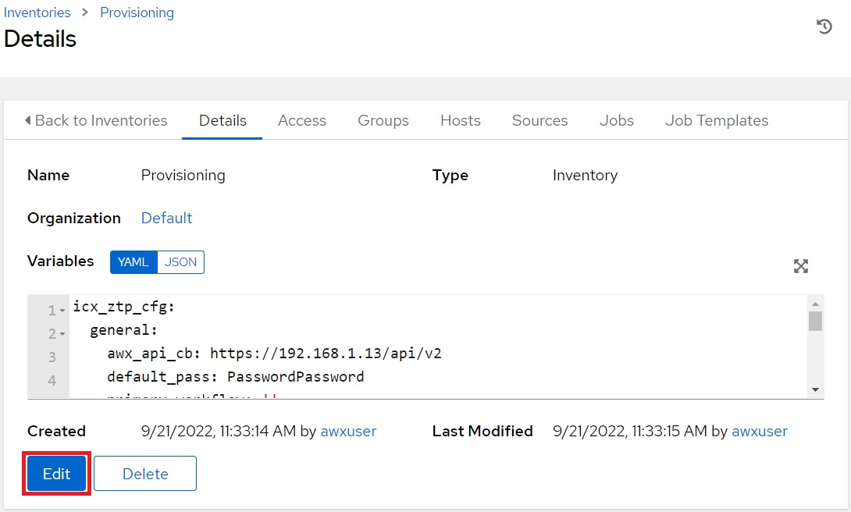

Find the inventory variable named icx_ztp_cfg.general.primary_workflow and define it with the name of the workflow as shown below, then click **Save**:

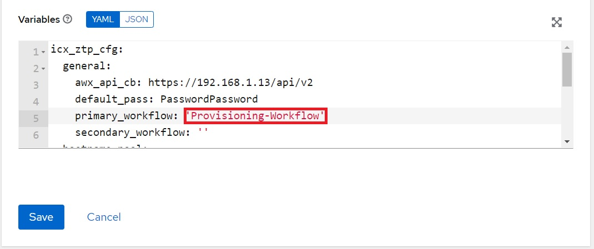

Note: Any templates placed after “*Provisioning-Finalize*” will fail if the hostname pool is configured. This is because “*Provisioning-Finalize*” will configure the switch with a hostname from the pool and it will change the name of the host in AWX. A second workflow can be created to make config changes after “*Provisioning-Finalize*”, such as configuring a default route for the static IP subnet. The variable, icx_ztp_cfg.general.secondary_workflow can be defined with the name of this workflow and it will be launch automatically upon completion of “*Provisioning-Finalize*”